Geethanjali College of Pharmacy
Approved by PCI New Delhi, Permanently Affiliated to JNTUH
Accredited by NBA (B. Pharmacy) & Accredited by NAAC (A+)
Recognized by DSIR-SIRO & HI/BI of MSME, Certified by ISO 9001:2015
Cheeryal (V), Keesara (M), Medchal-Malkajgiri Dist., Telangana State- 501303

PPT-Flow Chart (TLP method/ ICT Tool)
Date: 07.10.2025
Name of the Faculty: V. Shalini Designation: Asst Professor Department: Pharmacology
Presentation: PPT Presentation
Subject: Pathophysiology Class: B.Pharmacy I Year II sem
Unit /Topic: AIDS-Pathogenesis
Timings: 9:50 am to 10: 40 am
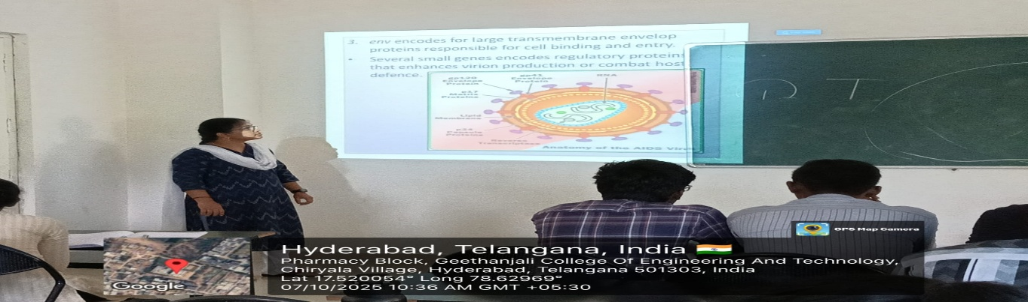
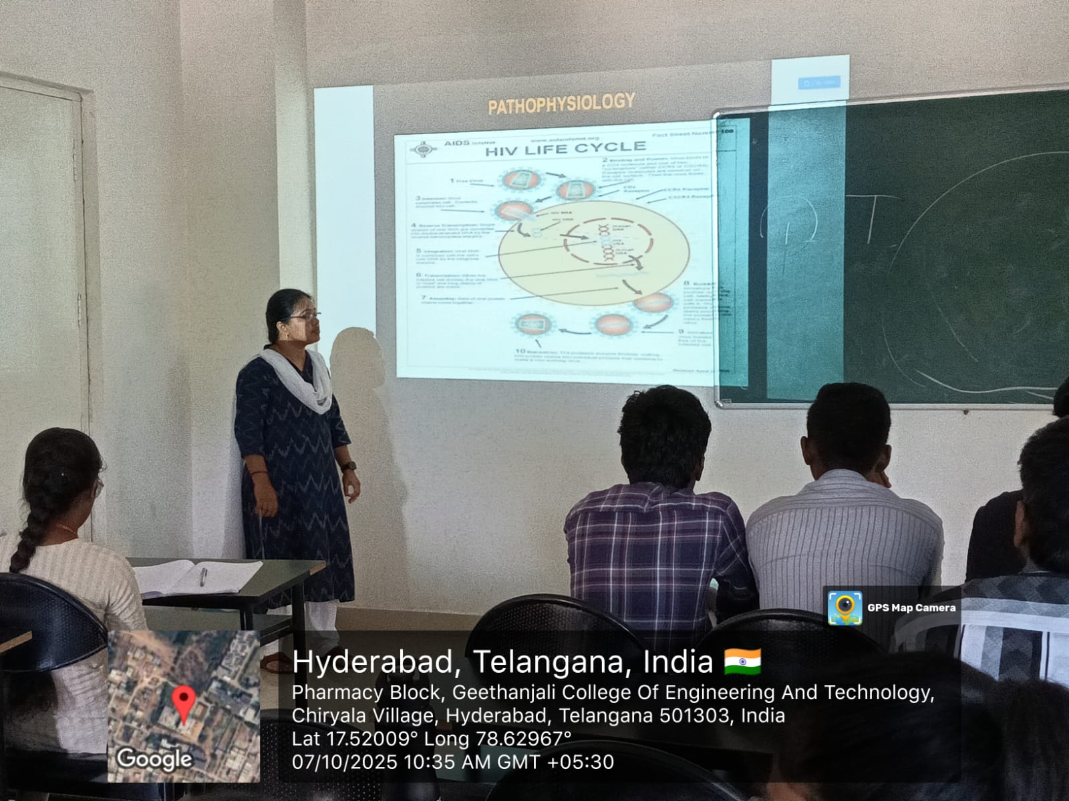
FACULTY HOD PRINCIPAL

Geethanjali College of Pharmacy
Approved by PCI New Delhi, Permanently Affiliated to JNTUH
Accredited by NBA (B. Pharmacy) & Accredited by NAAC (A+)
Recognized by DSIR-SIRO & HI/BI of MSME, Certified by ISO 9001:2015
Cheeryal (V), Keesara (M), Medchal-Malkajgiri Dist., Telangana State- 501303

PPT-Flow Chart
Date: 29.07.2025
Name of the Faculty: V. Shalini Designation: Asst Professor Department: Pharmacology
Presentation: PPT Presentation
Subject: Pathophysiology Class: B.Pharmacy I Year II sem
Unit /Topic: Thyroid Disorders
Timings: 10:40 am to 11: 30 am
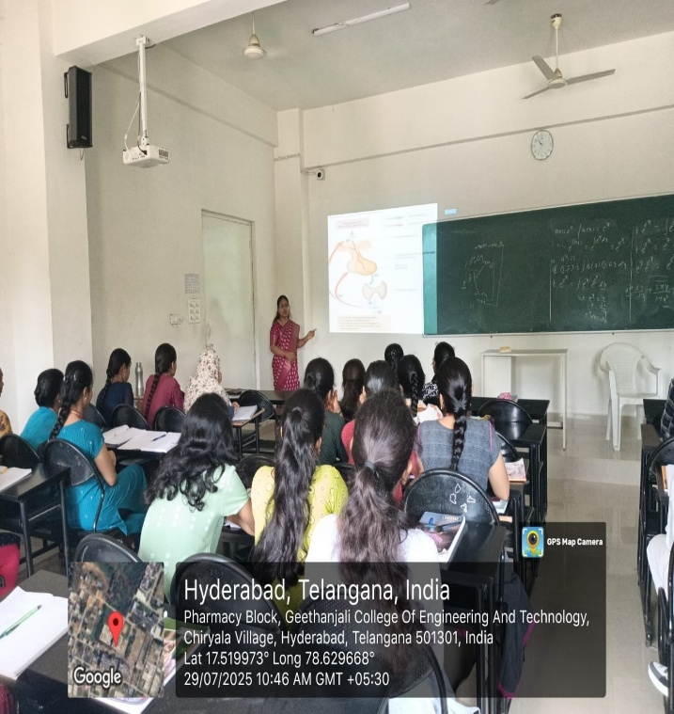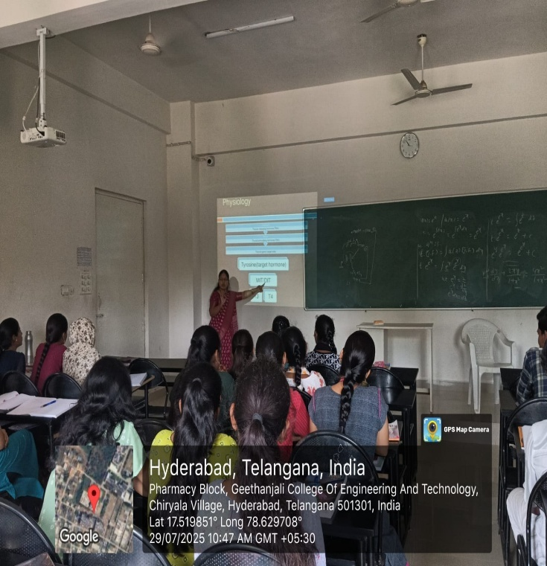

FACULTY HOD PRINCIPAL

Geethanjali College of Pharmacy
Approved by PCI New Delhi, Permanently Affiliated to JNTUH
Accredited by NBA (B. Pharmacy) & Accredited by NAAC (A+)
Recognized by DSIR-SIRO & HI/BI of MSME, Certified by ISO 9001:2015
Cheeryal (V), Keesara (M), Medchal-Malkajgiri Dist., Telangana State- 501303

PPT-Flow Chart
Date: 08.10.2025
Name of the Faculty: V. Shalini Designation: Asst Professor Department: Pharmacology
Presentation: PPT Presentation
Subject: Pathophysiology Class: B.Pharmacy I Year II sem
Unit /Topic: Thyroid Disorders- Pathogenesis
Timings: 1:00 pm to 1: 50 pm
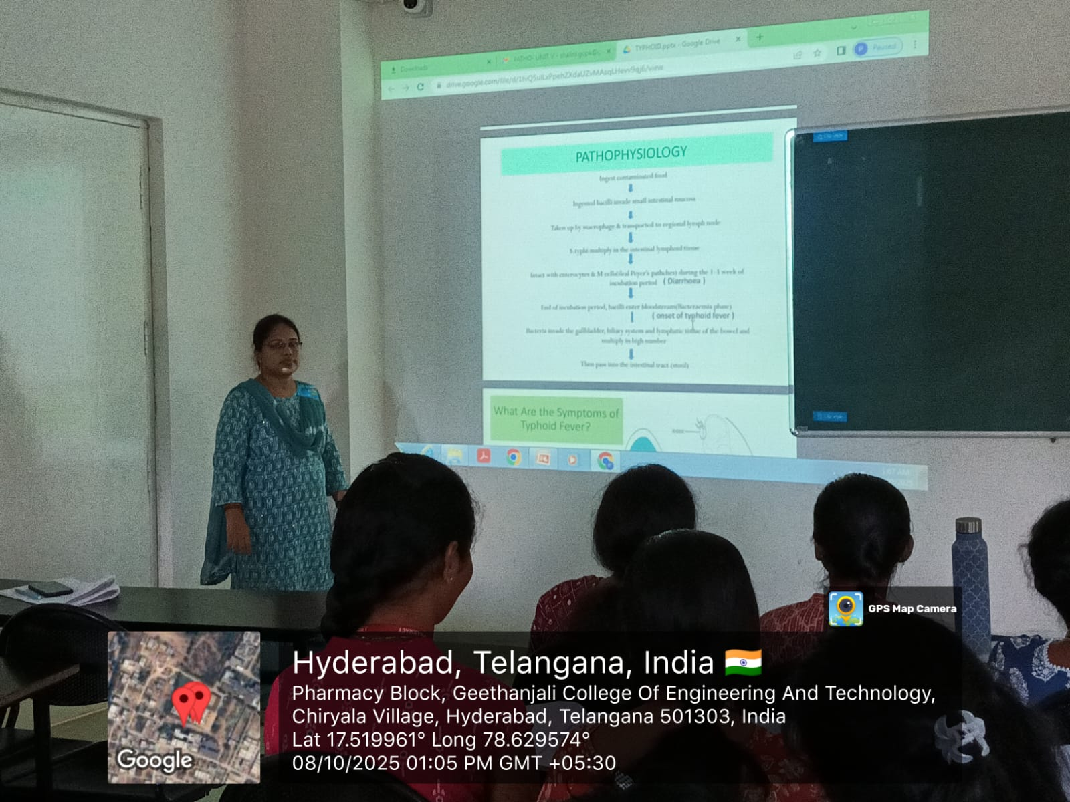

FACULTY HOD PRINCIPAL

Geethanjali College of Pharmacy
Approved by PCI New Delhi, Permanently Affiliated to JNTUH
Accredited by NBA (B. Pharmacy) & Accredited by NAAC (A+)
Recognized by DSIR-SIRO & HI/BI of MSME, Certified by ISO 9001:2015
Cheeryal (V), Keesara (M), Medchal-Malkajgiri Dist., Telangana State- 501303

PPT-Flow Chart
Date: 08.10.2025
Name of the Faculty: V. Shalini Designation: Asst Professor Department: Pharmacology
Presentation: PPT Presentation
Subject: Pathophysiology Class: B.Pharmacy I Year II sem
Unit /Topic: Syphilis-Stages and Pathogenesis
Timings: 12:10 pm to 1: 00 pm
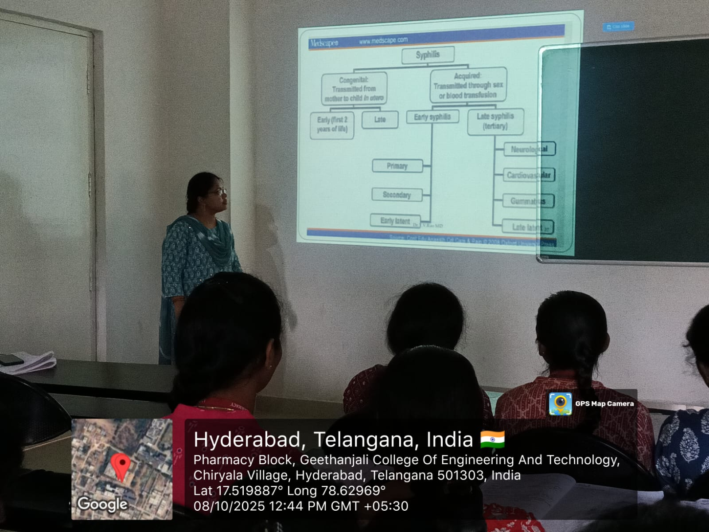

FACULTY HOD PRINCIPAL

Geethanjali College of Pharmacy
Approved by PCI New Delhi, Permanently Affiliated to JNTUH
Accredited by NBA (B. Pharmacy) & Accredited by NAAC (A+)
Recognized by DSIR-SIRO & HI/BI of MSME, Certified by ISO 9001:2015
Cheeryal (V), Keesara (M), Medchal-Malkajgiri Dist., Telangana State- 501303

Peer Teaching- Student Presentation
Date: 10.10.2025
Name of the Faculty: V. Shalini Designation: Asst Professor Department: Pharmacology
Presentation: Student Presentation
Subject: Pathophysiology Class: B.Pharmacy I Year II sem
Unit /Topic: Conjunctivitis-Types and Pathogenesis
Timings: 9:50 am to 10:40 am
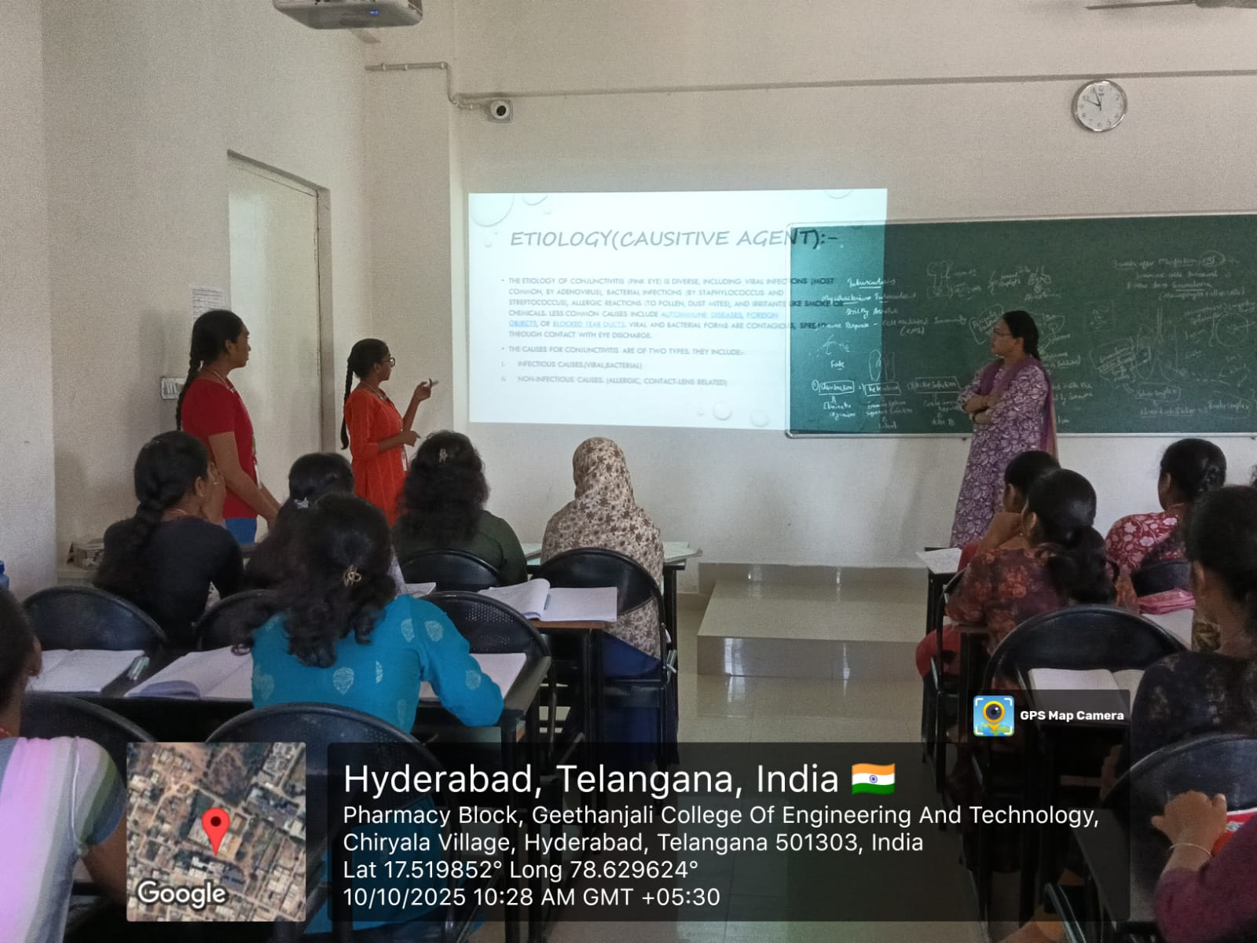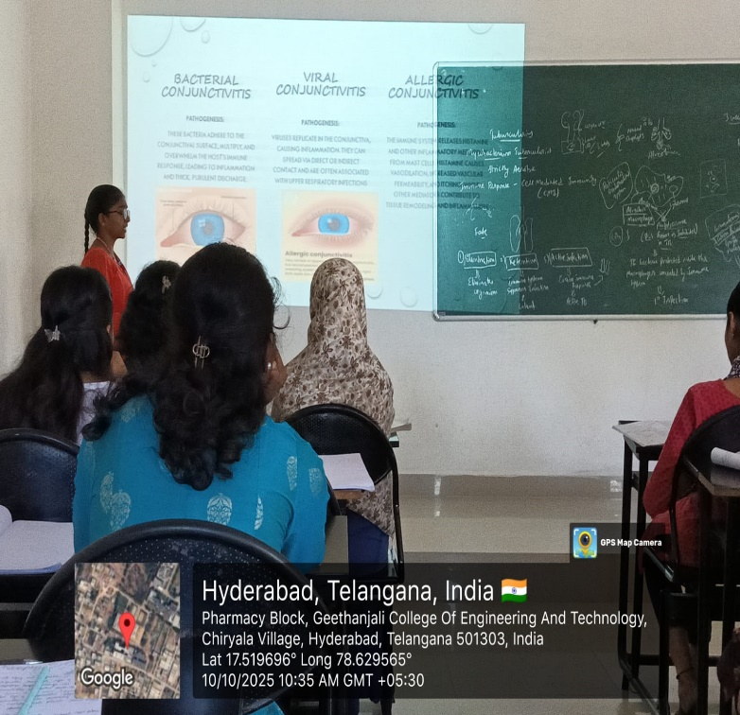

FACULTY HOD PRINCIPAL

Geethanjali College of Pharmacy
Approved by PCI New Delhi, Permanently Affiliated to JNTUH
Accredited by NBA (B. Pharmacy) & Accredited by NAAC (A+)
Recognized by DSIR-SIRO & HI/BI of MSME, Certified by ISO 9001:2015
Cheeryal (V), Keesara (M), Medchal-Malkajgiri Dist., Telangana State- 501303

Flipped Classroom-Peer Teaching
Date: 10.10.2025
Name of the Faculty: V. Shalini Designation: Asst Professor Department: Pharmacology
Presentation: Student Presentation
Subject: Pathophysiology Class: B.Pharmacy I Year II sem
Unit /Topic: SARS-COVID19- Pathogenesis
Timings: 10:40 am to 11:30 am
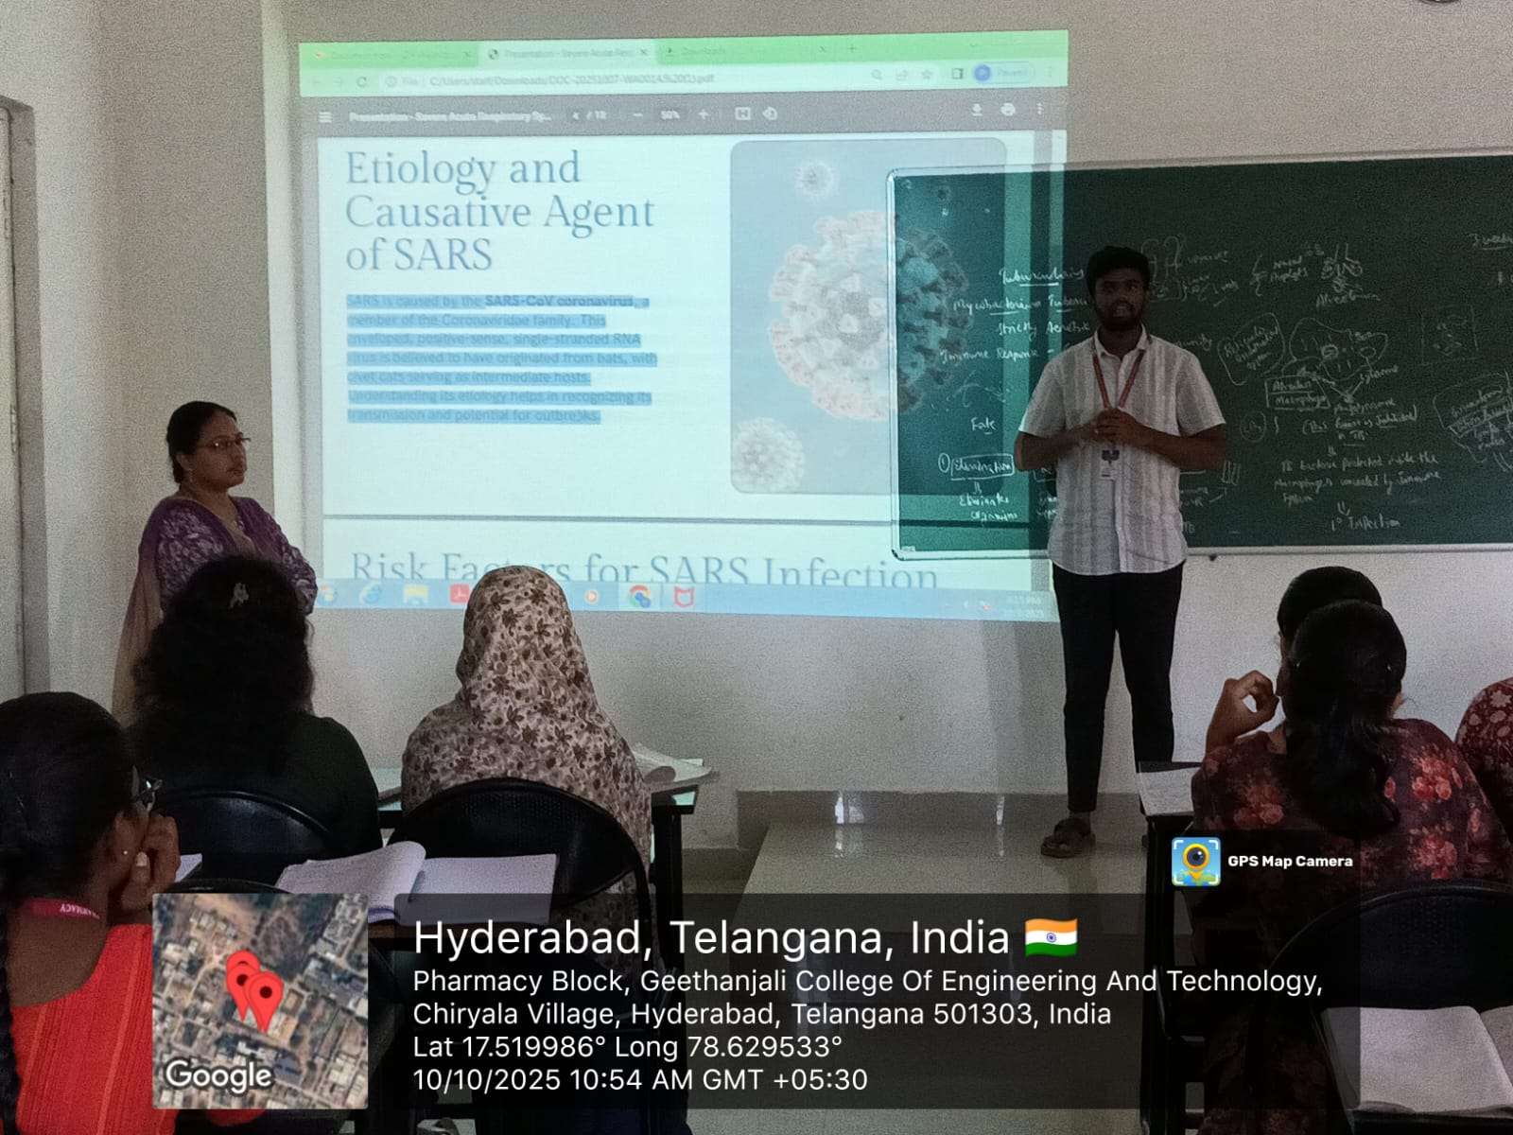

FACULTY HOD PRINCIPAL

Geethanjali College of Pharmacy
Approved by PCI New Delhi, Permanently Affiliated to JNTUH
Accredited by NBA (B. Pharmacy) & Accredited by NAAC (A+)
Recognized by DSIR-SIRO & HI/BI of MSME, Certified by ISO 9001:2015
Cheeryal (V), Keesara (M), Medchal-Malkajgiri Dist., Telangana State- 501303

QUIZ
Date: 01.08.2025
Name of the Faculty: V. Shalini Designation: Asst Professor Department: Pharmacology
Presentation: Student Presentation
Subject: Pathophysiology Class: B. Pharmacy I Year II sem
Unit /Topic: Sickle cell anaemia- Pathogenesis
Timings: 9:50 am to 10:40 am
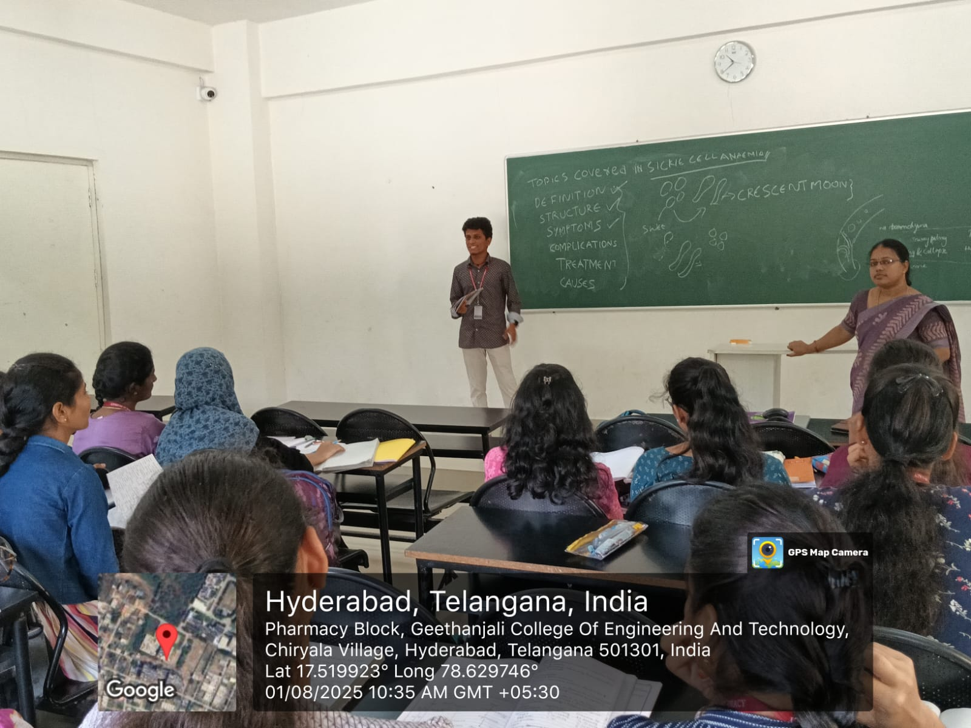

FACULTY HOD PRINCIPAL

Geethanjali College of Pharmacy
Approved by PCI New Delhi, Permanently Affiliated to JNTUH
Accredited by NBA (B. Pharmacy) & Accredited by NAAC (A+)
Recognized by DSIR-SIRO & HI/BI of MSME, Certified by ISO 9001:2015
Cheeryal (V), Keesara (M), Medchal-Malkajgiri Dist., Telangana State- 501303

Peer Teaching- Student Presentation
Date: 13.10.2025
Name of the Faculty: V. Shalini Designation: Asst Professor Department: Pharmacology
Presentation: Student Presentation
Subject: Pathophysiology Class: B.Pharmacy I Year II sem
Unit /Topic: Measles- Pathogenesis
Timings: 9:00 am to 9:50 am

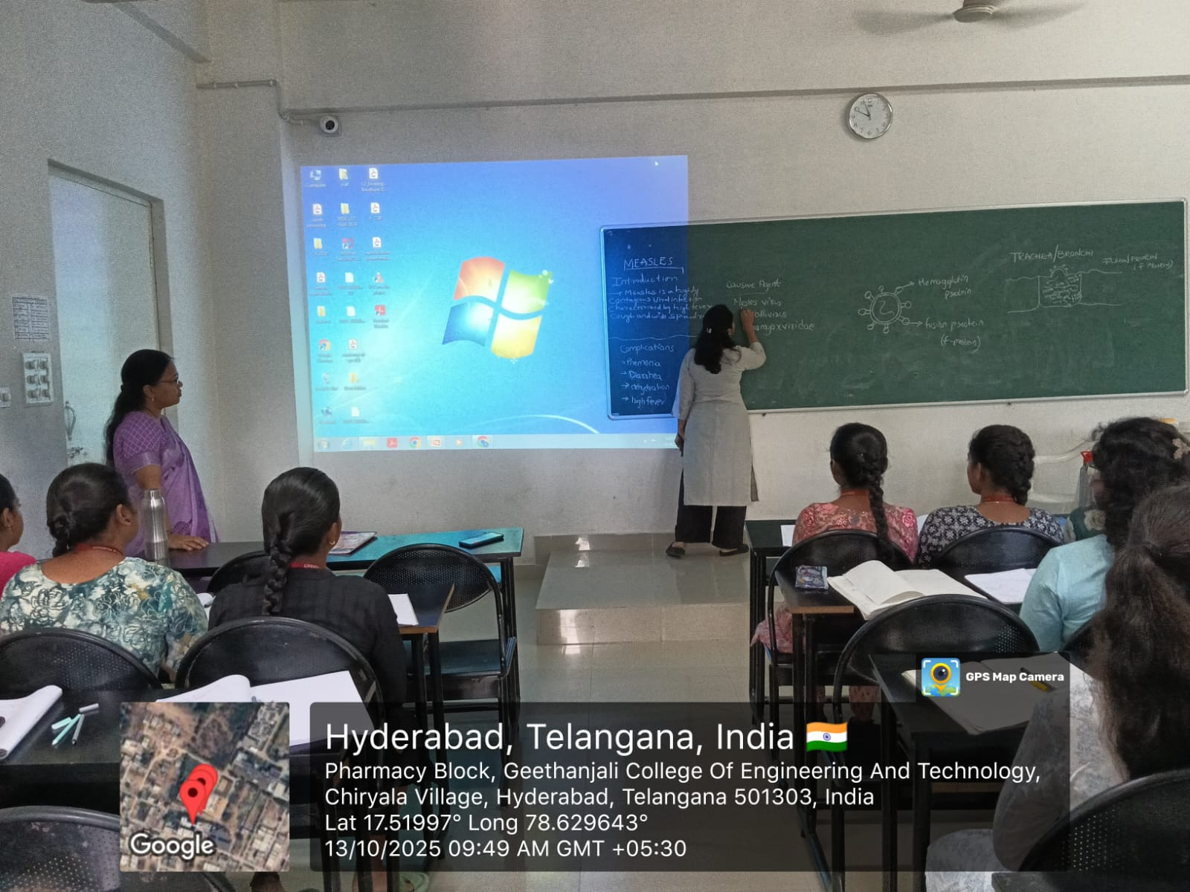

FACULTY HOD PRINCIPAL

Geethanjali College of Pharmacy
Approved by PCI New Delhi, Permanently Affiliated to JNTUH
Accredited by NBA (B. Pharmacy) & Accredited by NAAC (A+)
Recognized by DSIR-SIRO & HI/BI of MSME, Certified by ISO 9001:2015
Cheeryal (V), Keesara (M), Medchal-Malkajgiri Dist., Telangana State- 501303

COURSE OUTCOMES
Date: 19.09.2025
Name of the Faculty: V. Shalini Designation: Asst Professor Department: Pharmacology
Presentation: Student Presentation
Subject: Pathophysiology Class: B.Pharmacy I Year II sem
Unit /Topic: COURSE OUTCOMES
Timings: 9:50 am to 10:40 am
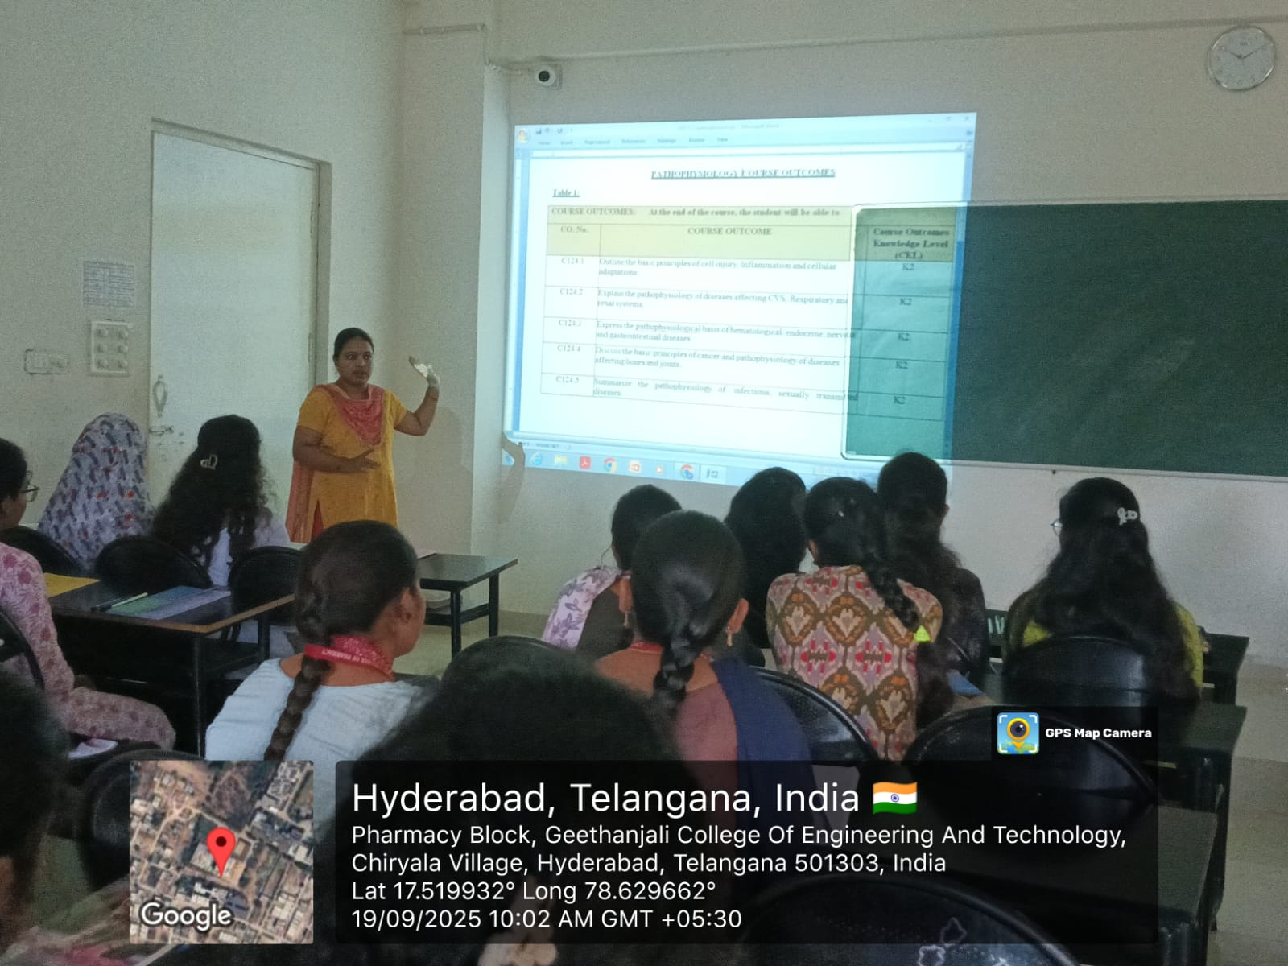

FACULTY HOD PRINCIPAL

Geethanjali College of Pharmacy
Approved by PCI New Delhi, Permanently Affiliated to JNTUH
Accredited by NBA (B. Pharmacy) & Accredited by NAAC (A+)
Recognized by DSIR-SIRO & HI/BI of MSME, Certified by ISO 9001:2015
Cheeryal (V), Keesara (M), Medchal-Malkajgiri Dist., Telangana State- 501303

Blended Learning- Blackboard and PPT Presentation (TLP method/ ICT Tool)
Date: 10.10.2025
Name of the Faculty: V. Shalini Designation: Asst Professor Department: Pharmacology
Presentation: PPT Presentation
Subject: Pathophysiology Class: B.Pharmacy I Year II sem
Unit /Topic: Meningitis- Pathogenesis
Timings: 9:50 am to 10:40 am
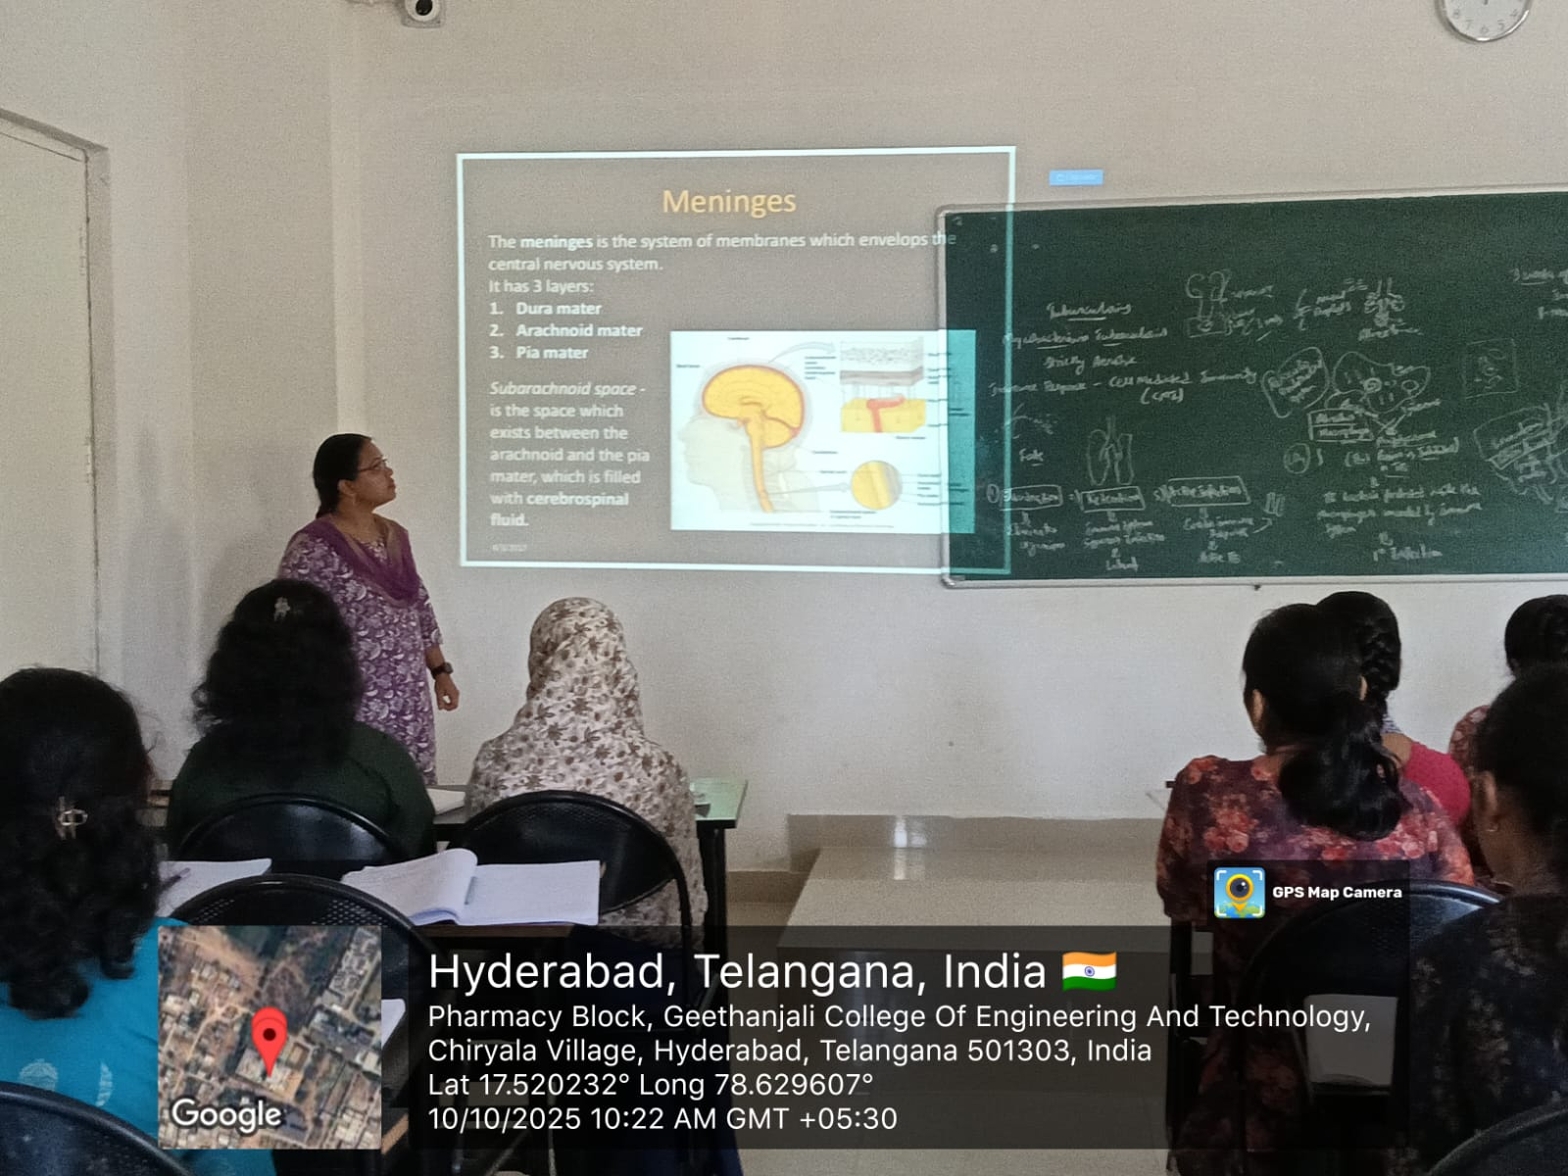

FACULTY HOD PRINCIPAL

Geethanjali College of Pharmacy
Approved by PCI New Delhi, Permanently Affiliated to JNTUH
Accredited by NBA (B. Pharmacy) & Accredited by NAAC (A+)
Recognized by DSIR-SIRO & HI/BI of MSME, Certified by ISO 9001:2015
Cheeryal (V), Keesara (M), Medchal-Malkajgiri Dist., Telangana State- 501303

Flowchart- PPT Presentation
Date: 20.09.2025
Name of the Faculty: V. Shalini Designation: Asst Professor Department: Pharmacology
Presentation: PPT Presentation
Subject: Pathophysiology Class: B. Pharmacy I Year II sem
Unit /Topic: Rheumatoid Arthritis- Pathogenesis
Timings: 9:00 am to 9:50 am
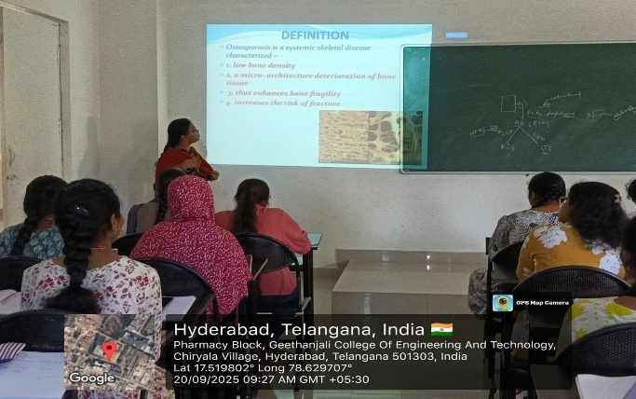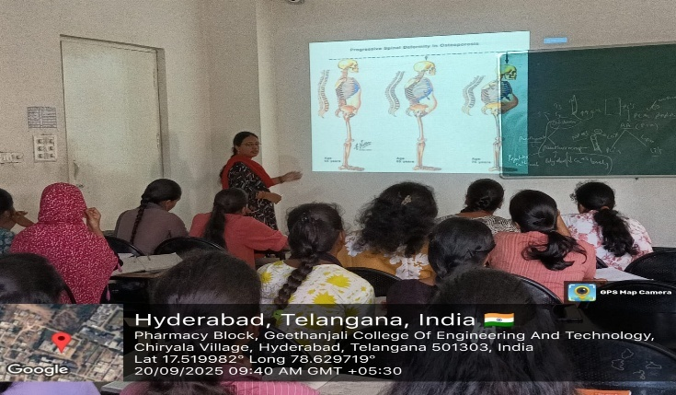
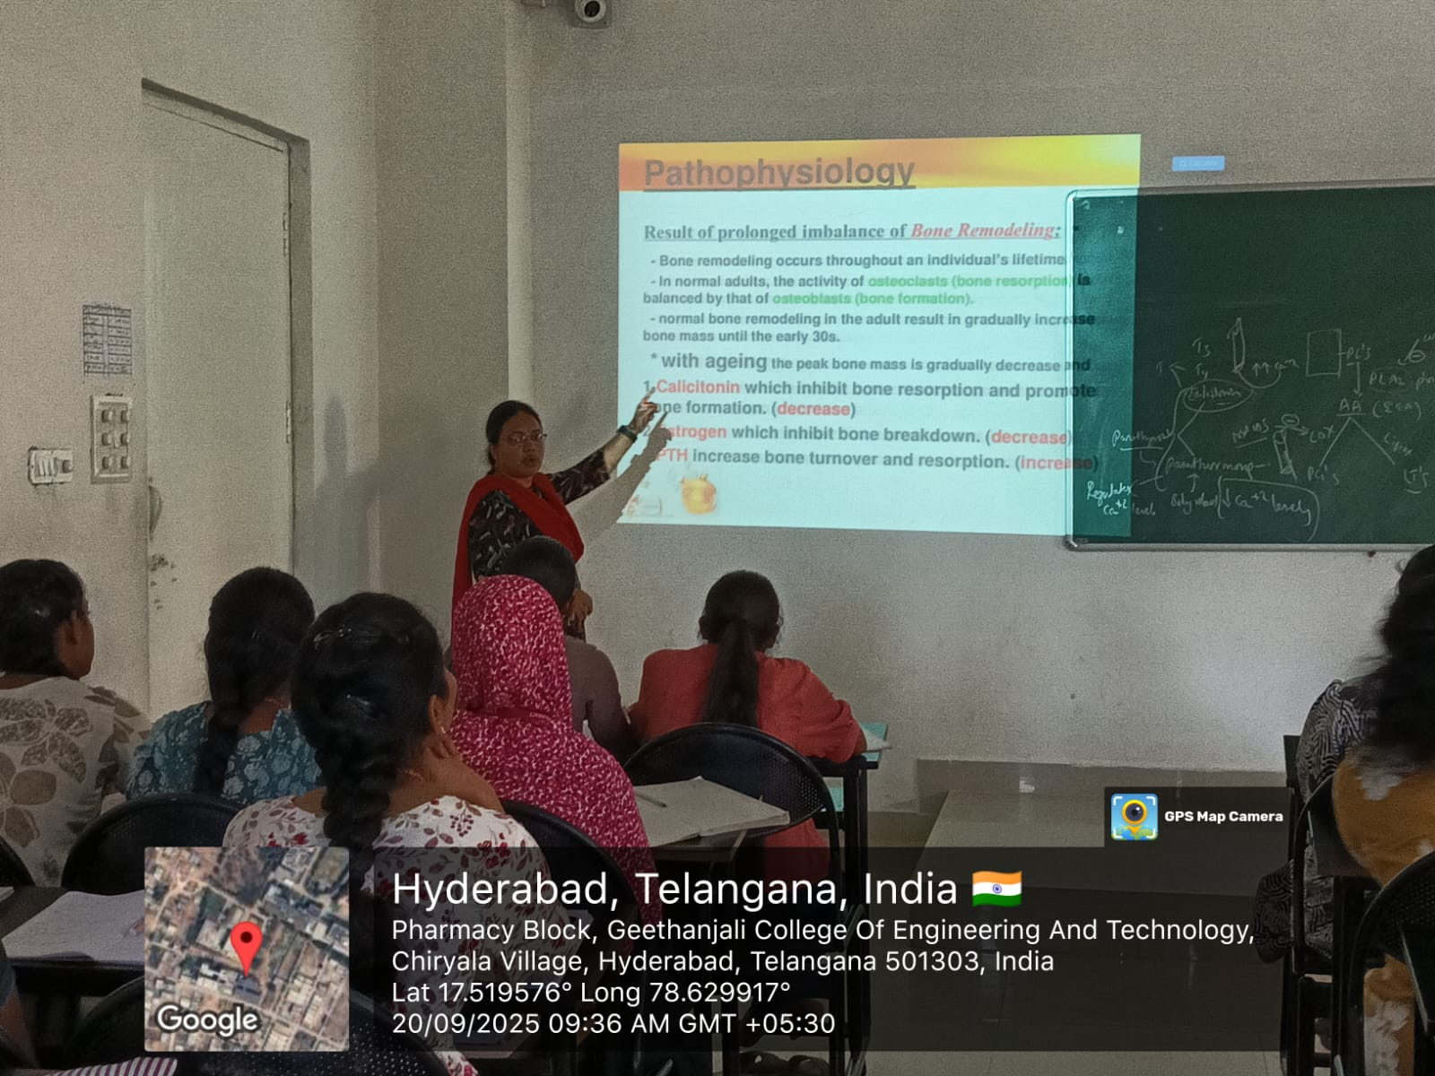
FACULTY HOD PRINCIPAL

Geethanjali College of Pharmacy
Approved by PCI New Delhi, Permanently Affiliated to JNTUH
Accredited by NBA (B. Pharmacy) & Accredited by NAAC (A+)
Recognized by DSIR-SIRO & HI/BI of MSME, Certified by ISO 9001:2015
Cheeryal (V), Keesara (M), Medchal-Malkajgiri Dist., Telangana State- 501303

Flowchart- PPT Presentation
Date: 20.09.2025
Name of the Faculty: V. Shalini Designation: Asst Professor Department: Pharmacology
Presentation: PPT Presentation
Subject: Pathophysiology Class: B.Pharmacy I Year II sem
Unit /Topic: Gout- Pathogenesis
Timings: 9:00 am to 9:50 am
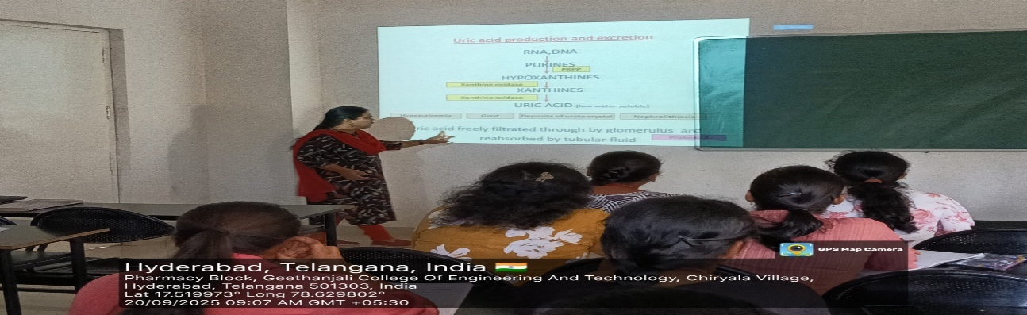
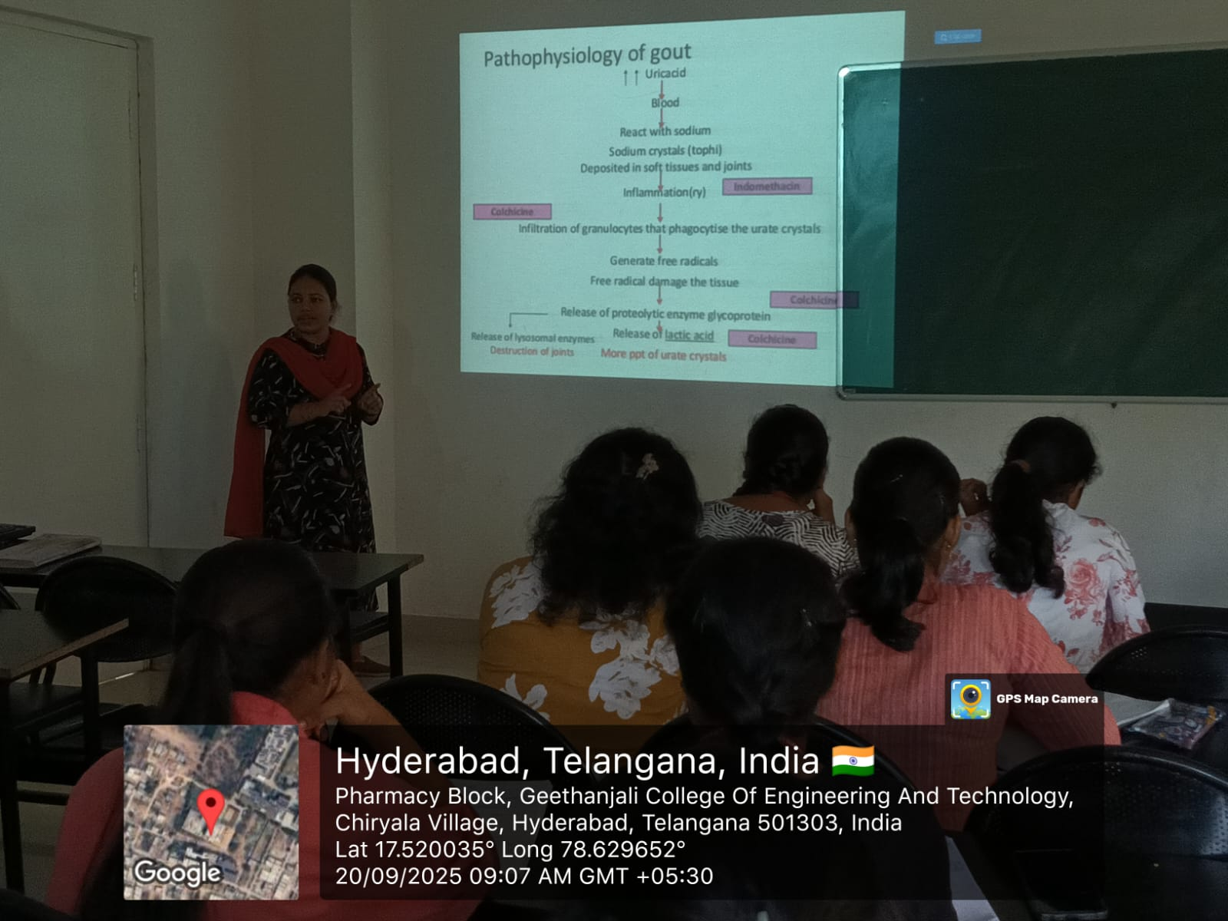

FACULTY HOD PRINCIPAL

Geethanjali College of Pharmacy
Approved by PCI New Delhi, Permanently Affiliated to JNTUH
Accredited by NBA (B. Pharmacy) & Accredited by NAAC (A+)
Recognized by DSIR-SIRO & HI/BI of MSME, Certified by ISO 9001:2015
Cheeryal (V), Keesara (M), Medchal-Malkajgiri Dist., Telangana State- 501303

Flow Chart
Date: 16.12.2025
Name of the Faculty: S. Rani Designation: Asst Professor Department: Pharmaceutics
Subject: General Pharmacy Class: B.Pharmacy I Year I sem
Unit /Topic: Classification of Dosage forms
Timings: 9:00 am to 9: 50 am
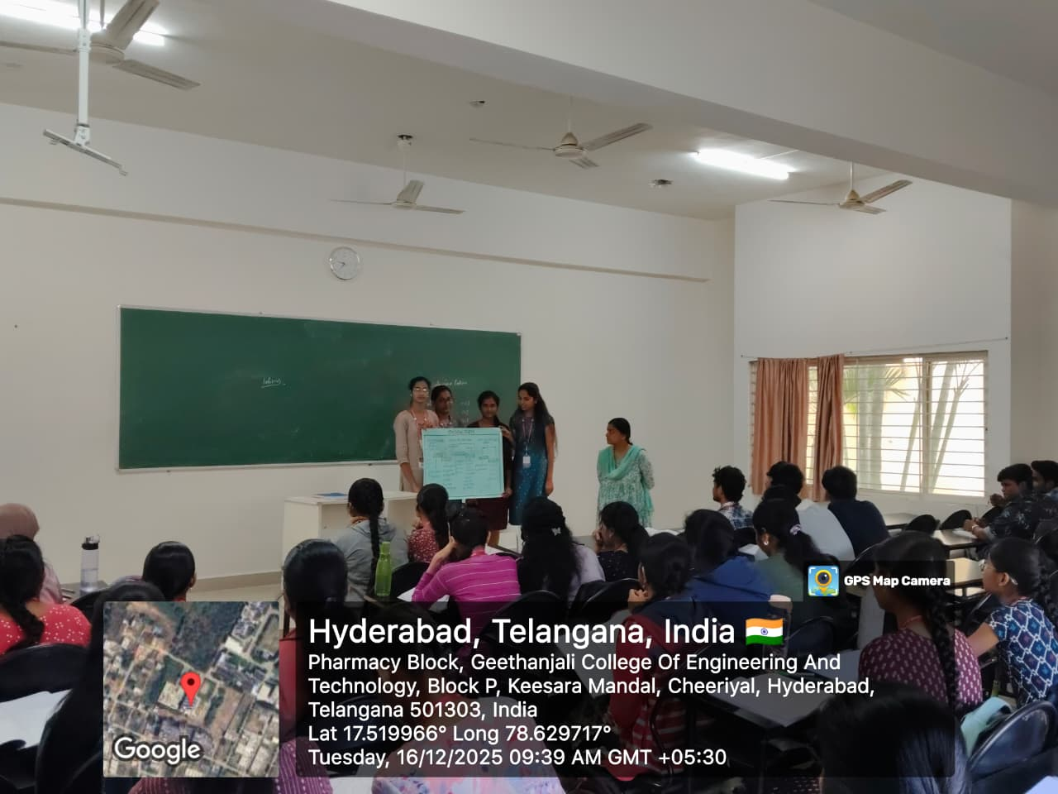

FACULTY HOD PRINCIPAL

Geethanjali College of Pharmacy
Approved by PCI New Delhi, Permanently Affiliated to JNTUH
Accredited by NBA (B. Pharmacy) & Accredited by NAAC (A+)
Recognized by DSIR-SIRO & HI/BI of MSME, Certified by ISO 9001:2015
Cheeryal (V), Keesara (M), Medchal-Malkajgiri Dist., Telangana State- 501303

Mindmap
Date: 22.07.2025
Name of the Faculty: B.Anitha Designation: Asst Professor Department: Pharmaceutics
Subject: Physical Pharmaceutics-II Class: B.Pharmacy II Year II sem
Unit /Topic: Emulsions
Timings: 1:00 pm to 1: 50 pm

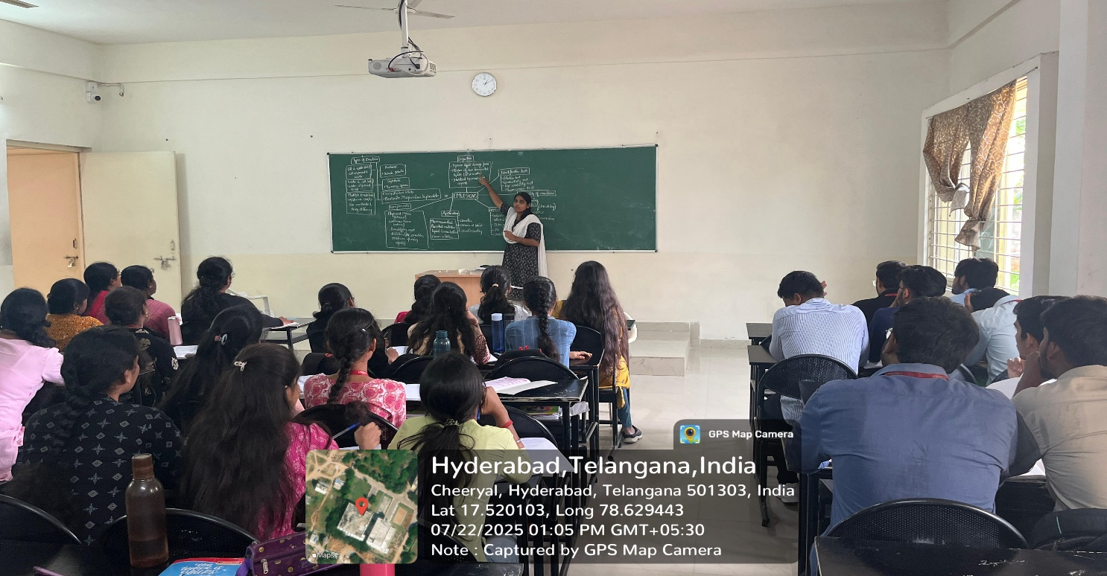

FACULTY HOD PRINCIPAL

Geethanjali College of Pharmacy
Approved by PCI New Delhi, Permanently Affiliated to JNTUH
Accredited by NBA (B. Pharmacy) & Accredited by NAAC (A+)
Recognized by DSIR-SIRO & HI/BI of MSME, Certified by ISO 9001:2015
Cheeryal (V), Keesara (M), Medchal-Malkajgiri Dist., Telangana State- 501303

QUIZ
Date: 22.07.2025
Name of the Faculty: B. Anitha Designation: Asst Professor Department: Pharmaceutics
Subject: Physical Pharmaceutics-II Class: B.Pharmacy II Year II sem
Unit /Topic: Emulsions
Timings: 1:00 pm to 1: 50 pm

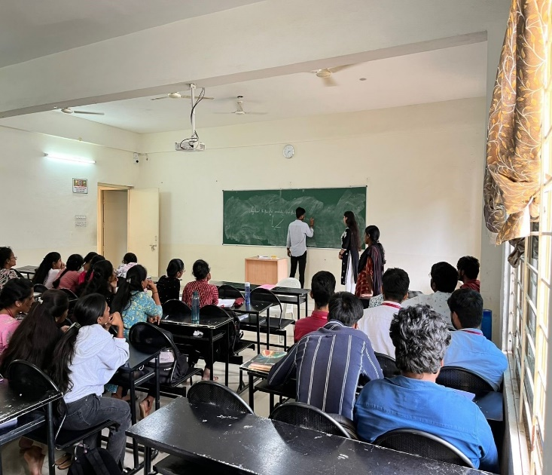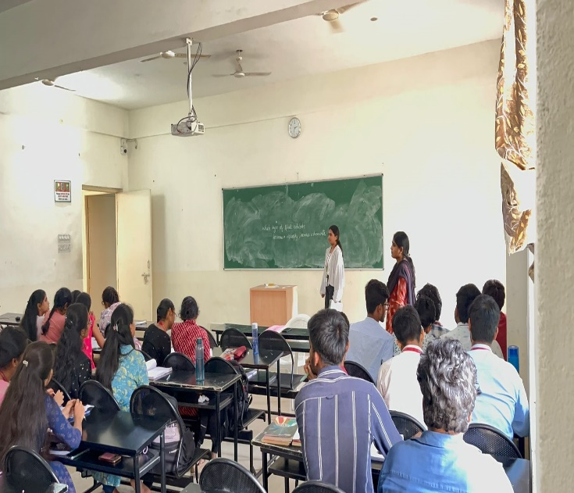

FACULTY HOD PRINCIPAL

Geethanjali College of Pharmacy
Approved by PCI New Delhi, Permanently Affiliated to JNTUH
Accredited by NBA (B. Pharmacy) & Accredited by NAAC (A+)
Recognized by DSIR-SIRO & HI/BI of MSME, Certified by ISO 9001:2015
Cheeryal (V), Keesara (M), Medchal-Malkajgiri Dist., Telangana State- 501303

Lab based Learning
Date: 29.04.2026
Name of the Faculty: G.Abhinayani Designation: Asst Professor Department: Pharmacology
Presentation: Experimental Learning
Subject: Human Anatomy Physiology and Pathophysiology-I
Class: B.Pharmacy I Year II sem
Unit /Topic: Determination of Bleeding and Clotting time
Timings: 9:00 am to 12:10 pm

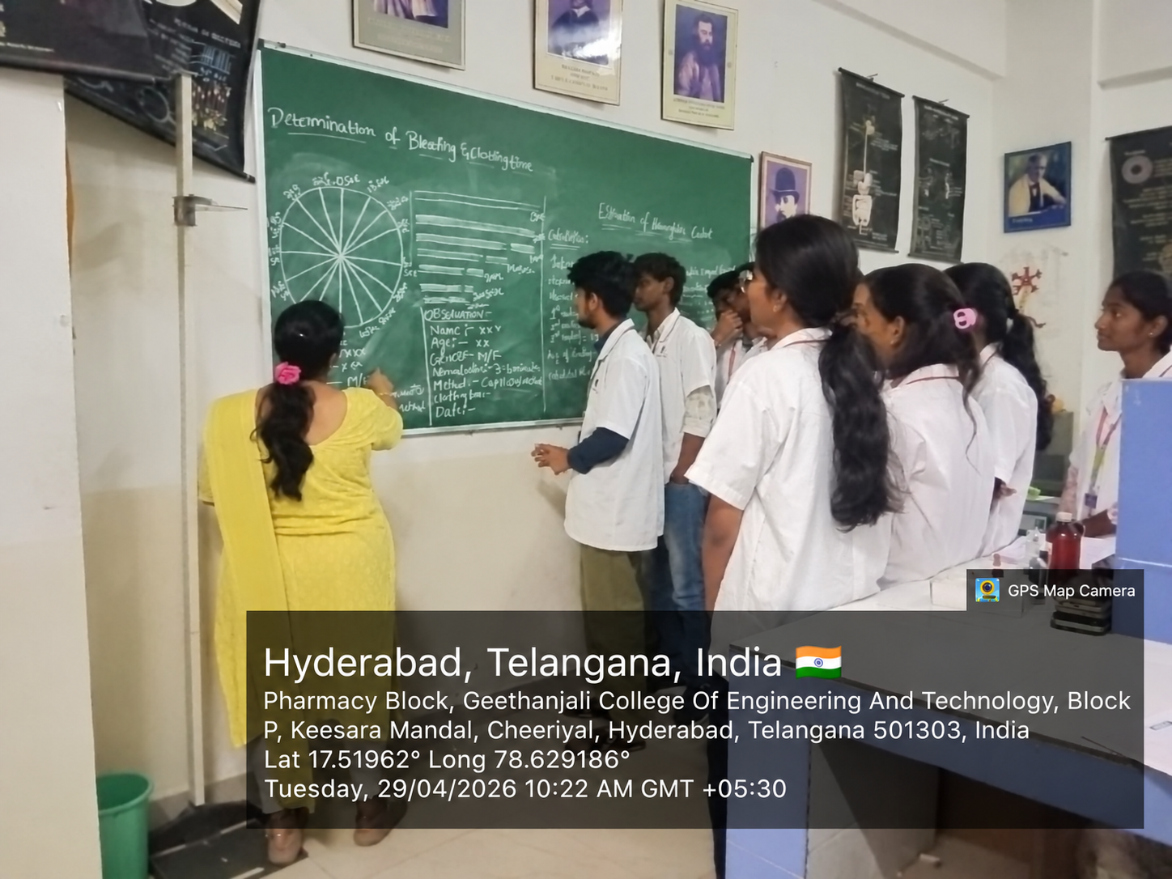

FACULTY HOD PRINCIPAL

Geethanjali College of Pharmacy
Approved by PCI New Delhi, Permanently Affiliated to JNTUH
Accredited by NBA (B. Pharmacy) & Accredited by NAAC (A+)
Recognized by DSIR-SIRO & HI/BI of MSME, Certified by ISO 9001:2015
Cheeryal (V), Keesara (M), Medchal-Malkajgiri Dist., Telangana State- 501303

Lab based Learning
Date: 06.05.2026
Name of the Faculty: G. Abhinayani Designation: Asst Professor Department: Pharmacology
Presentation: Experimental Learning
Subject: Human Anatomy Physiology and Pathophysiology-I
Class: B.Pharmacy I Year II sem
Unit /Topic: Determination of Haemoglobin content
Timings: 9:00 am to 12:10 pm

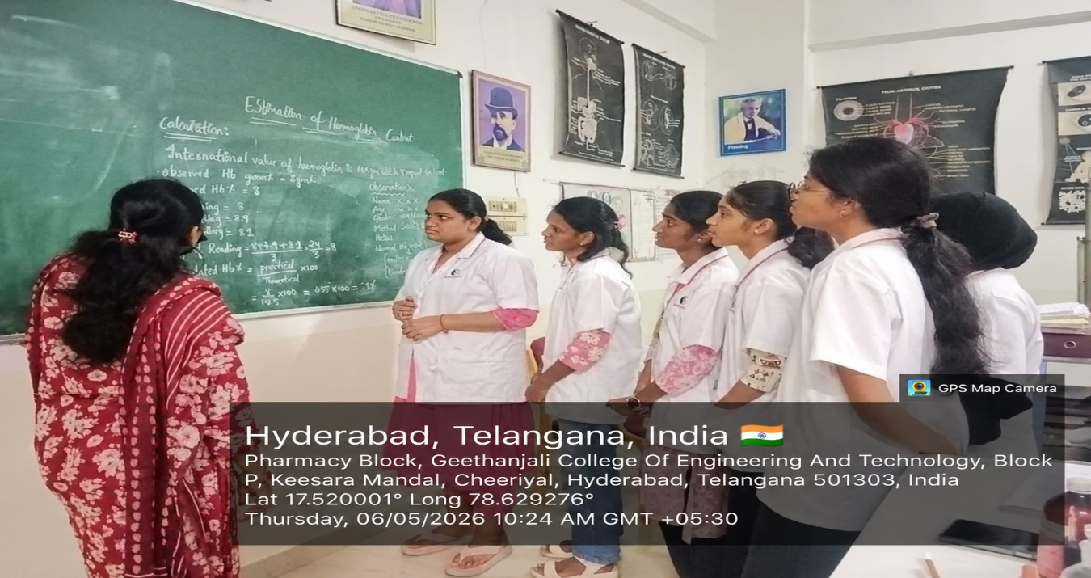

FACULTY HOD PRINCIPAL

Geethanjali College of Pharmacy
Approved by PCI New Delhi, Permanently Affiliated to JNTUH
Accredited by NBA (B. Pharmacy) & Accredited by NAAC (A+)
Recognized by DSIR-SIRO & HI/BI of MSME, Certified by ISO 9001:2015
Cheeryal (V), Keesara (M), Medchal-Malkajgiri Dist., Telangana State- 501303

Seminar Presentations
Date: 25.06.2026
Name of the Faculty: G. Abhinayani Designation: Asst Professor Department: Pharmacology
Subject: Human Anatomy Physiology and Pathophysiology-I
Class: B.Pharmacy I Year II sem
Unit /Topic: Cell and Tissues
Timings: 1:50 pm to 2:40 pm

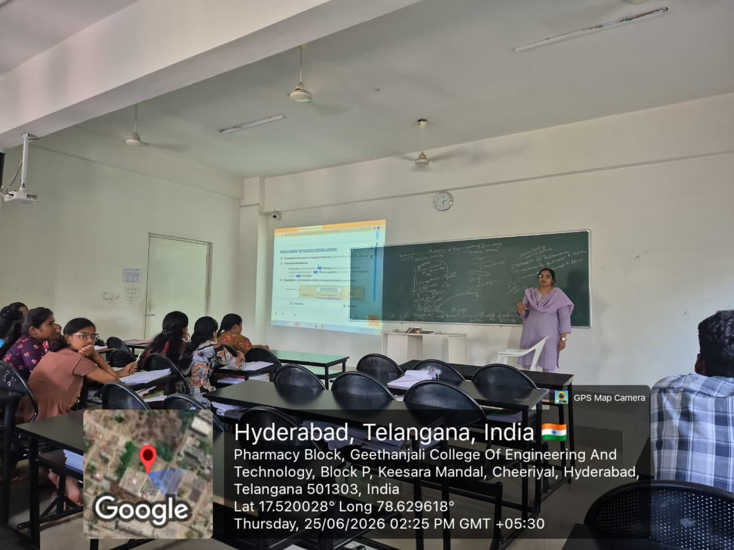

FACULTY HOD PRINCIPAL

 |  | Geethanjali College of Pharmacy  UGC AUTONOMOUS |  | 
Approved by PCI New Delhi, Affiliated to JNTUH, Accredited by NAAC with an A+ Grade,
Accredited by NBA (B. Pharmacy) Recognized by DSIR’s SIRO and ISO 9001:2015 Certified.
Cheeryal (V), Keesara (M), Medchal-Malkajgiri Dist.- Telangana State- 501303.
Experimental Learning (Lab based Learning)
Date: 23.09.2026
Name of the Faculty: Mrs. L. Saritha Designation: Asst Professor Department: Pharmacology
Presentation: Experimental Learning
Subject: Human Anatomy Physiology and Pathophysiology-II
Class: B. Pharmacy II Year I sem
Unit /Topic: Determination of Haemoglobin content
Timings: 9:00 am to 12:10 pm
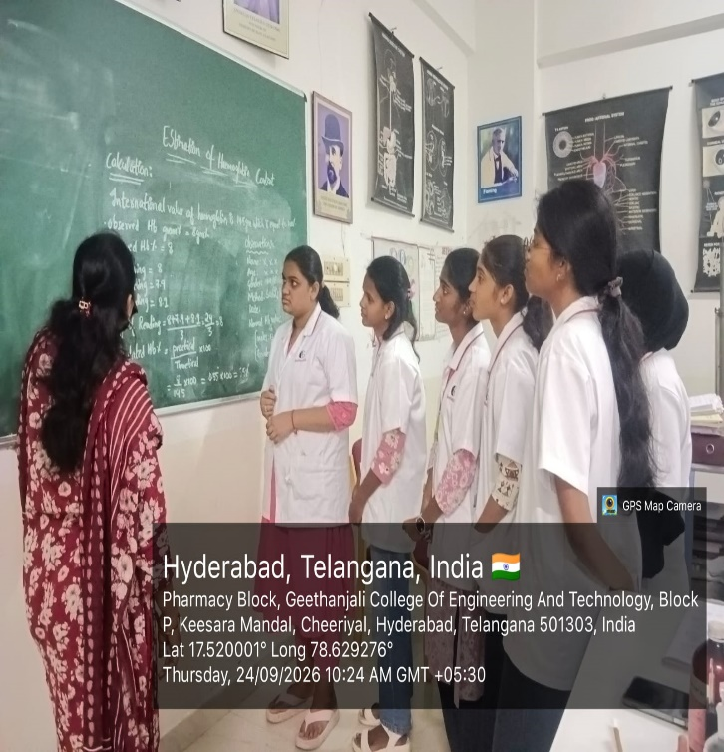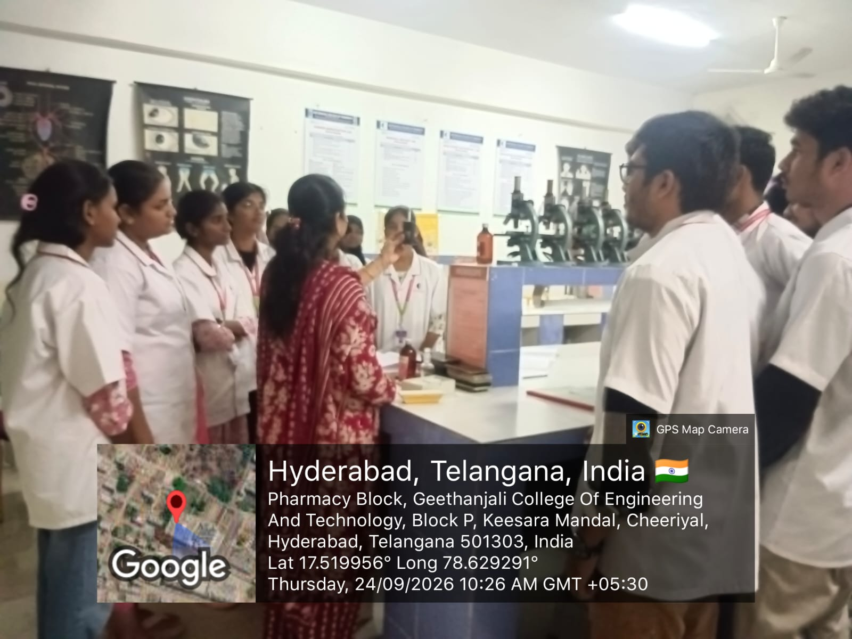

FACULTY HOD PRINCIPAL

Geethanjali College of Pharmacy

UGC AUTONOMOUS
Approved by PCI New Delhi, Affiliated to JNTUH, Accredited by NAAC with an A+ Grade,
Accredited by NBA (B. Pharmacy) Recognized by DSIR’s SIRO and ISO 9001:2015 Certified.
Cheeryal (V), Keesara (M), Medchal-Malkajgiri Dist.- Telangana State- 501303.
Experimental Learning (Lab based Learning)
Date: 17.07.2026
Name of the Faculty: Mrs. S. Rani Designation: Asst Professor Department: Pharmaceutics
Presentation: Experimental Learning
Subject: Biopharmaceutics and Pharmacokinetics
Class: B. Pharmacy III Year II sem
Unit /Topic: Diffusion studies of Diclofenac gel by Franz diffusion cell
Timings: 12:10 pm to 3:20 pm

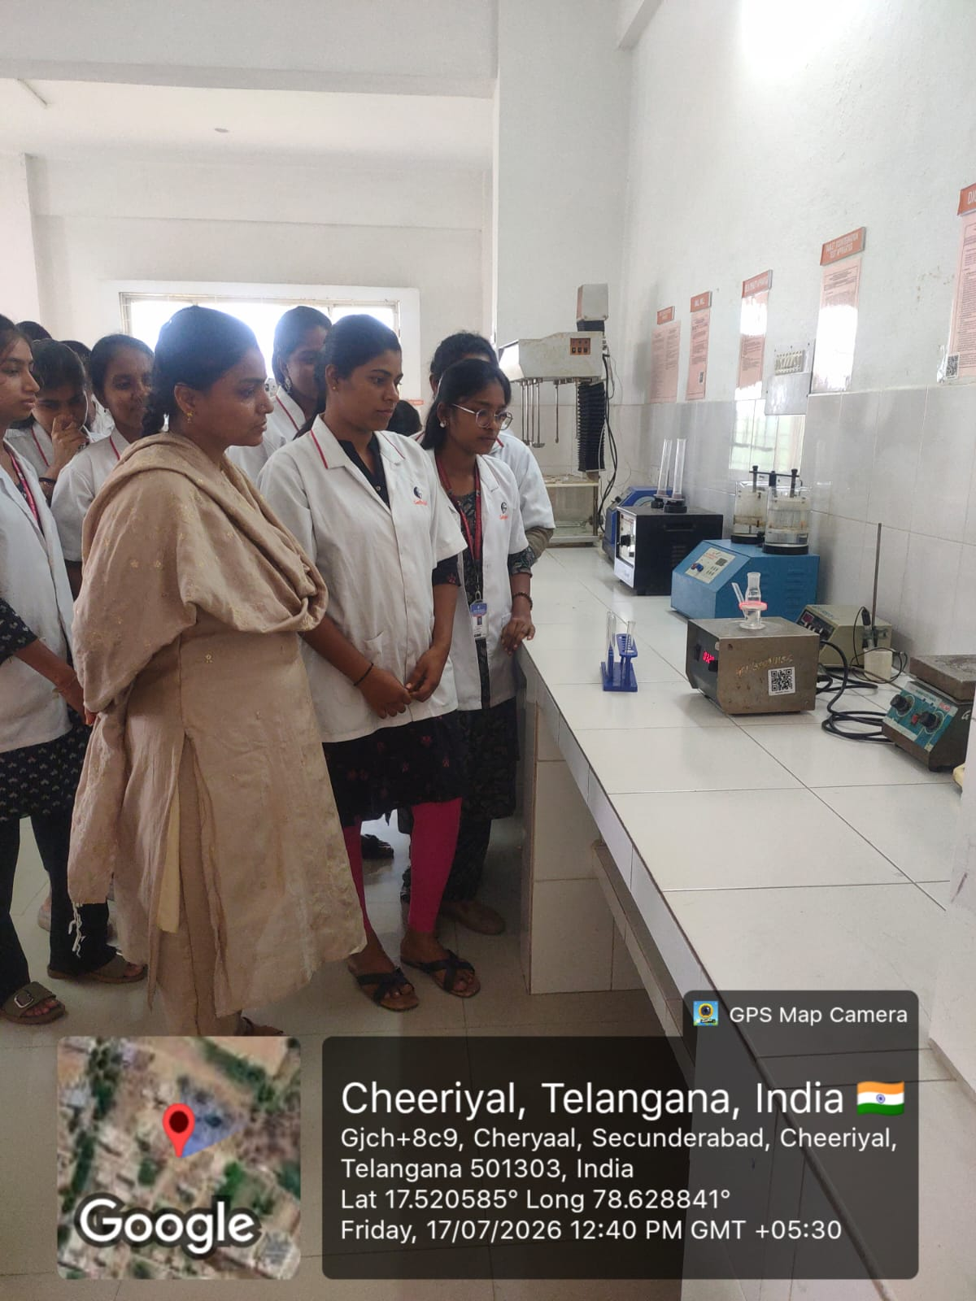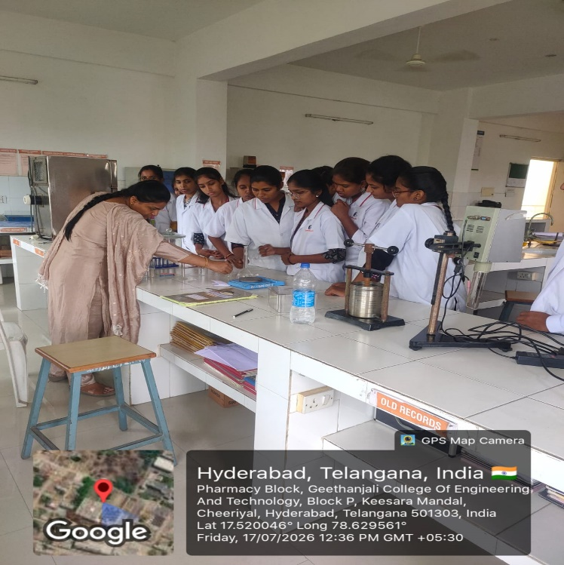

FACULTY HOD PRINCIPAL

Geethanjali College of Pharmacy

UGC AUTONOMOUS
Approved by PCI New Delhi, Affiliated to JNTUH, Accredited by NAAC with an A+ Grade,
Accredited by NBA (B. Pharmacy) Recognized by DSIR’s SIRO and ISO 9001:2015 Certified.
Cheeryal (V), Keesara (M), Medchal-Malkajgiri Dist.- Telangana State- 501303.
Experimental Learning (Lab based Learning)
Date: 03.07.2026
Name of the Faculty: Mrs. S. Rani Designation: Asst Professor Department: Pharmaceutics
Presentation: Experimental Learning
Subject: Biopharmaceutics and Pharmacokinetics
Class: B. Pharmacy III Year II Sem
Unit /Topic: Estimation of Pharmacokinetic parameters of a drug given orally following one compartment open model using method of residuals
Timings: 12:10 pm to 3:20 pm

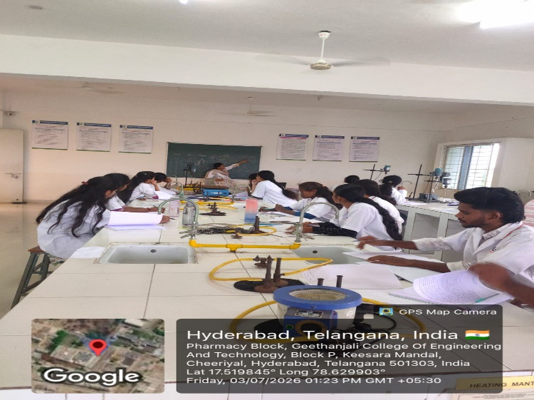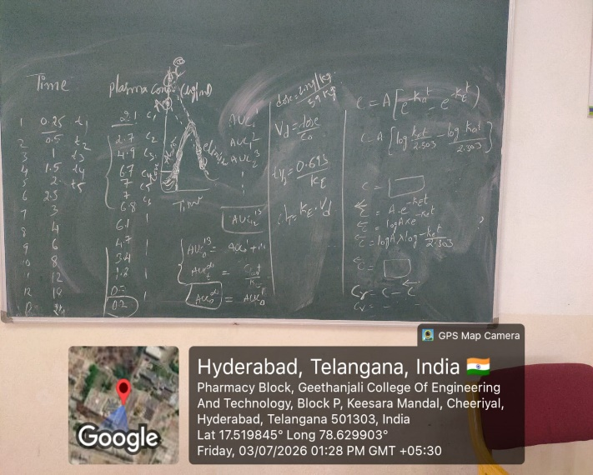

FACULTY HOD PRINCIPAL

Geethanjali College of Pharmacy

UGC AUTONOMOUS
Approved by PCI New Delhi, Affiliated to JNTUH, Accredited by NAAC with an A+ Grade,
Accredited by NBA (B. Pharmacy) Recognized by DSIR’s SIRO and ISO 9001:2015 Certified.
Cheeryal (V), Keesara (M), Medchal-Malkajgiri Dist.- Telangana State- 501303.
Problem based learning (PBL)
Date: 03.07.2026
Name of the Faculty: Sandya Rani G Designation: Associate Professor
Department: Pharmaceutical Chemistry
Presentation: Experimental Learning
Subject: Pharmaceutical Organic Chemistry -III
Class: B. Pharmacy II Year II Sem
Timings: 12:10 pm to 3:20 pm
Unit /Topic: A Problem-Based Learning (PBL) Teaching-Learning Plan on “Conformational Isomerism of n-Butane” was conducted in the class to enhance students’ conceptual understanding through active learning. The session began with how rotation around the central carbon-carbon bond in n-butane leads to different conformations and variations in stability. Students worked collaboratively in groups, using molecular models and Newman projections to identify anti, gauche, eclipsed, and fully eclipsed conformations. Through discussion, analysis, and interpretation of energy profiles, they explored the role of steric and torsional strain in determining conformational stability. The activity promoted critical thinking, problem-solving, and teamwork, enabling students to conclude that the anti-conformation is the most stable form of n-butane. Overall, the PBL approach made the topic more engaging, interactive, and effective for meaningful learning.

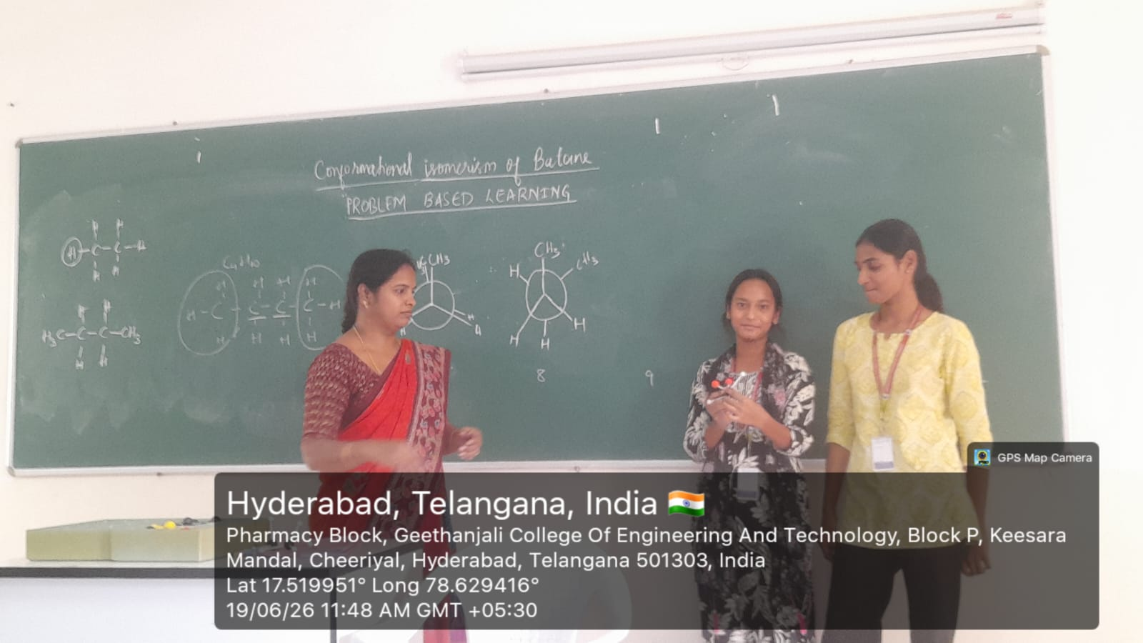

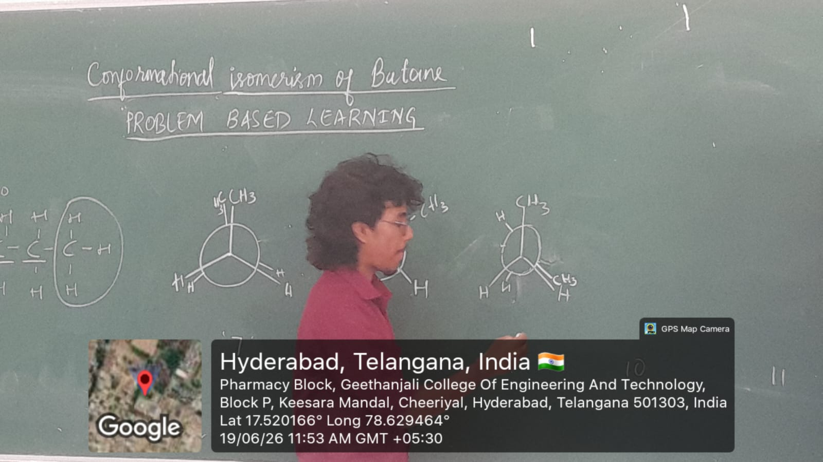

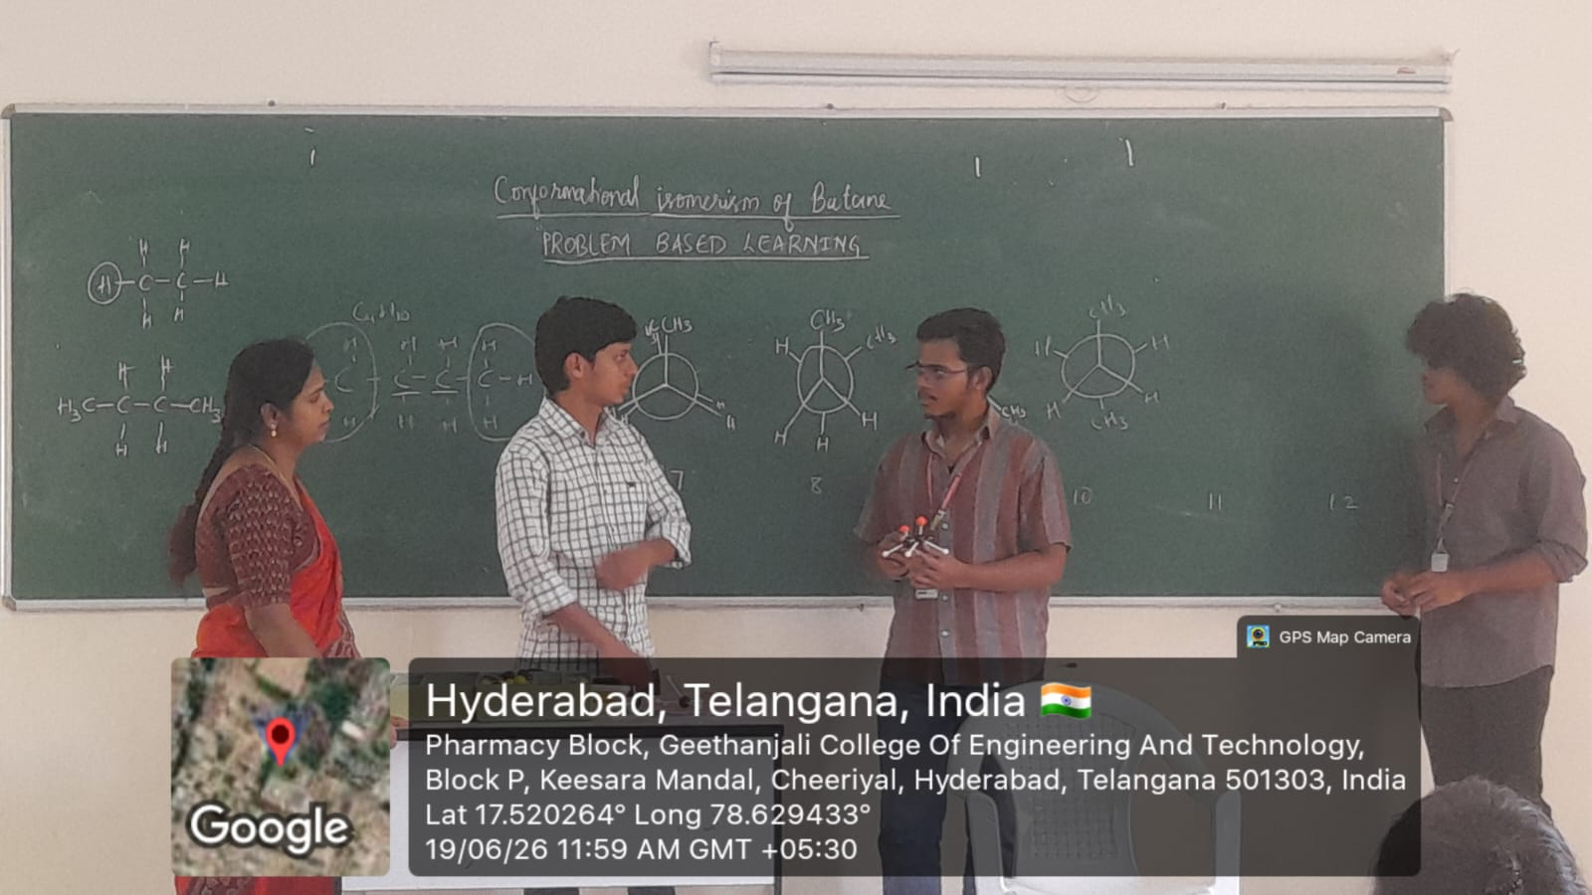

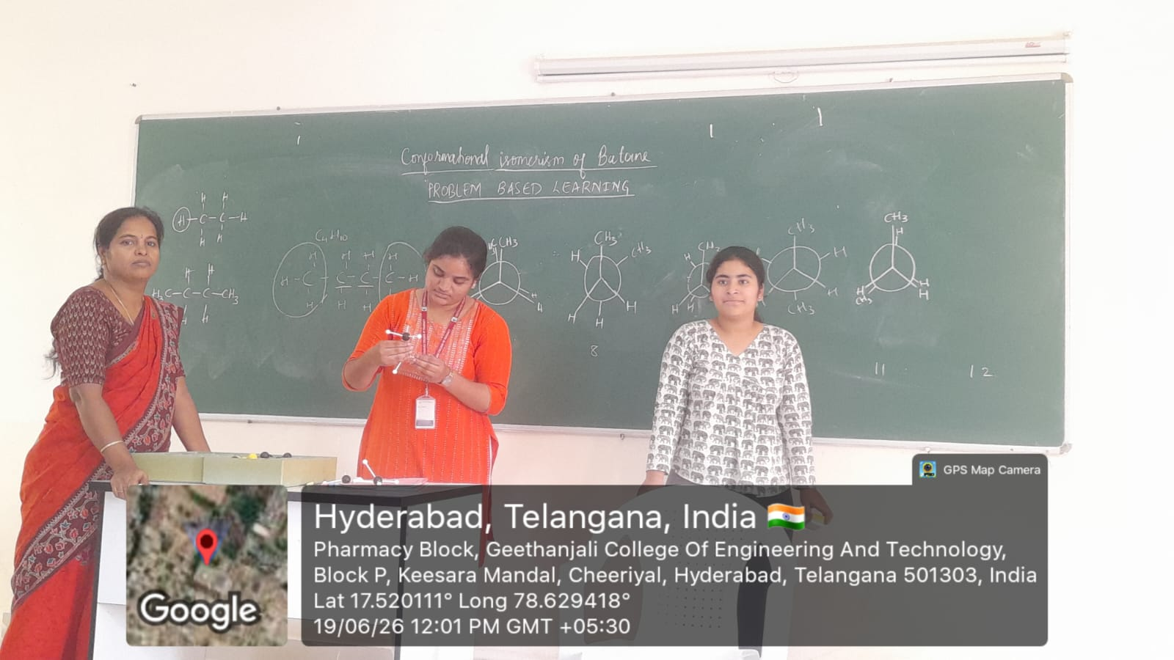

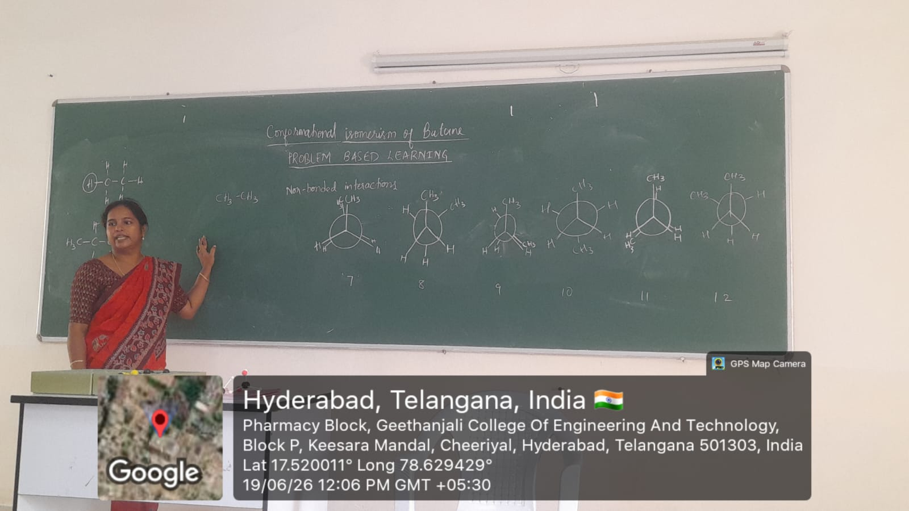

FACULTY HOD PRINCIPAL

Geethanjali College of Pharmacy
Approved by PCI New Delhi, Permanently Affiliated to JNTUH
Accredited by NBA (B. Pharmacy) & Accredited by NAAC (A+)
Recognized by DSIR-SIRO & HI/BI of MSME, Certified by ISO 9001:2015
Cheeryal (V), Keesara (M), Medchal-Malkajgiri Dist., Telangana State- 501303

Problem based learning (PBL)
Date: 30.12.2025
Name of the Faculty: Sandya Rani G Designation: Associate Professor
Department: Pharmaceutical Chemistry
Presentation: Experimental Learning
Subject: Pharmaceutical Organic Chemistry -III Class: B. Pharmacy II Year II Sem
Topic: Unit – II/ Nomenclature of Aromatic acids
Timings: 12:10 pm to 3:20 pm
Class used for problem-solving (Students are permitted to use nomenclature guidelines for their own structures that fall under the aromatic acid class).
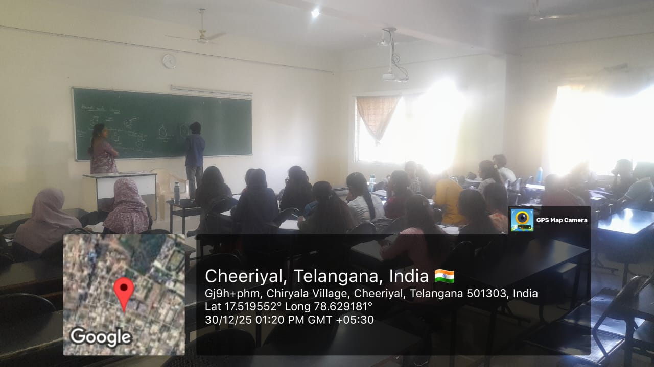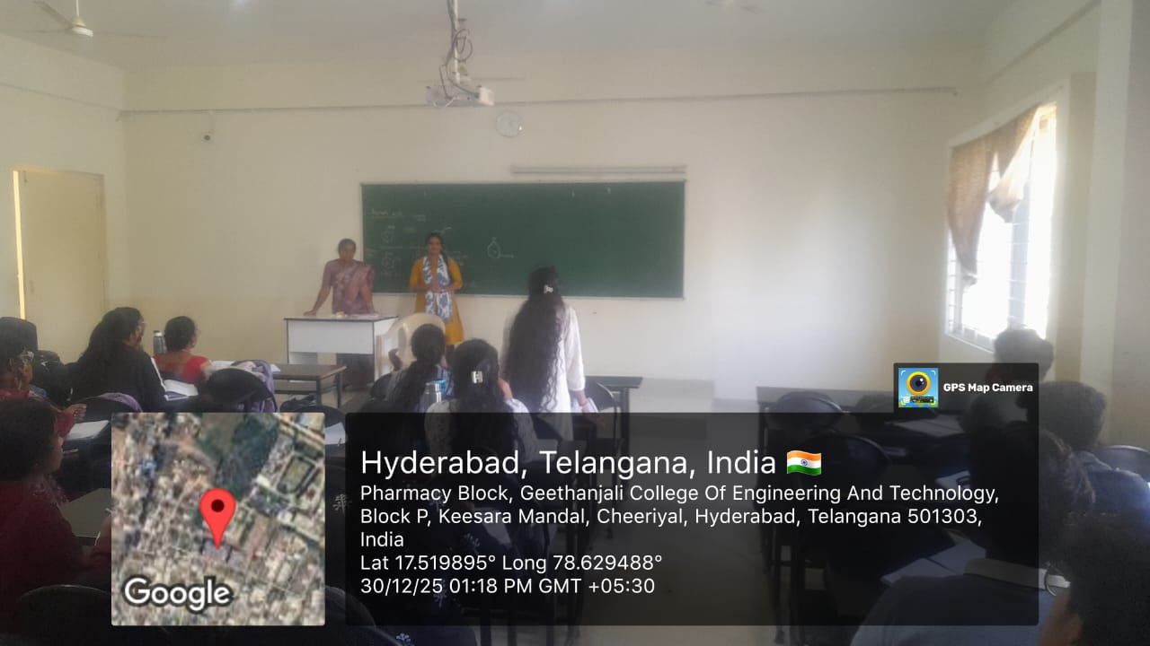

FACULTY HOD PRINCIPAL

Geethanjali College of Pharmacy

UGC AUTONOMOUS
Approved by PCI New Delhi, Affiliated to JNTUH, Accredited by NAAC with an A+ Grade,
Accredited by NBA (B. Pharmacy) Recognized by DSIR’s SIRO and ISO 9001:2015 Certified.
Cheeryal (V), Keesara (M), Medchal-Malkajgiri Dist.- Telangana State- 501303.
QUIZ
Date: 20.06.2026
Name of the Faculty: Sandya Rani G Designation: Associate Professor
Department: Pharmaceutical Chemistry
Subject: Pharmaceutical Organic Chemistry -III
Class: B. Pharmacy II Year II Sem
Timings: 12:10 pm to 3:20 pm

A quiz was conducted to assess students’ understanding of important named reactions, including their reagents, reaction mechanisms, intermediates, and applications. Multiple-choice questions were used to reinforce concepts such as Clemmensen reduction, Wolff–Kishner reduction, Birch reduction, Oppenauer oxidation, Dakin reaction, Beckmann rearrangement, Schmidt reaction, Pinacol–Pinacolone rearrangement, and Claisen–Schmidt condensation. The activity encouraged active participation, rapid recall, and identification of appropriate reagents and reaction outcomes.
Learning Outcome:
Students were able to recall and differentiate named reactions, identify suitable reagents and mechanisms, and predict the major products of important organic transformations.

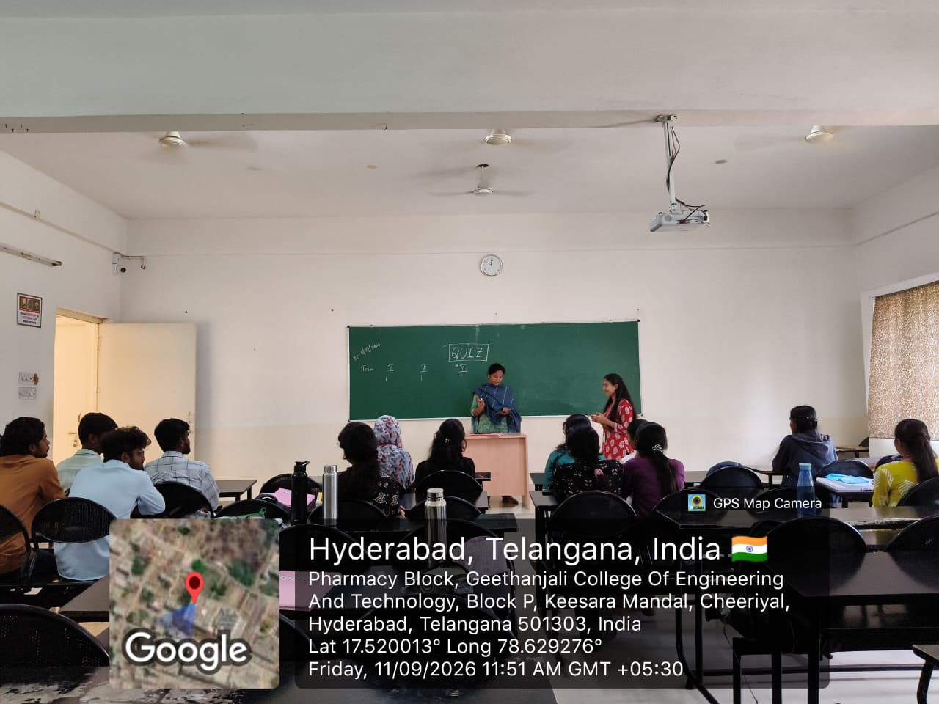

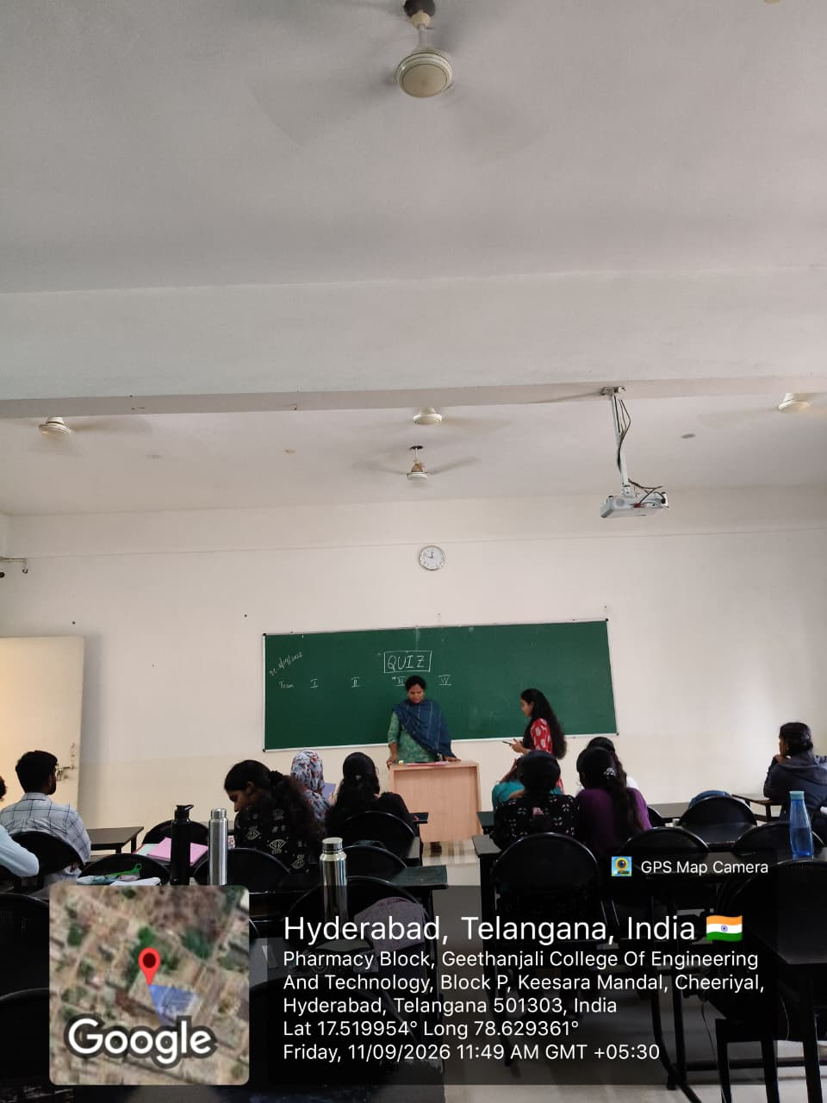

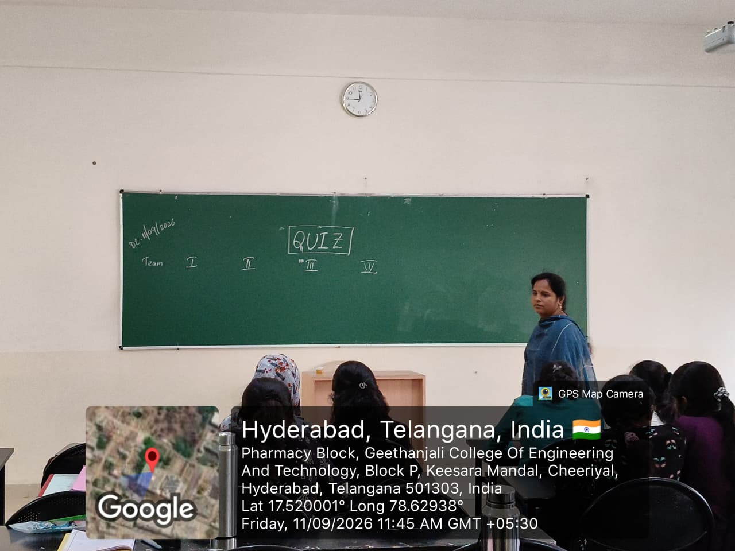
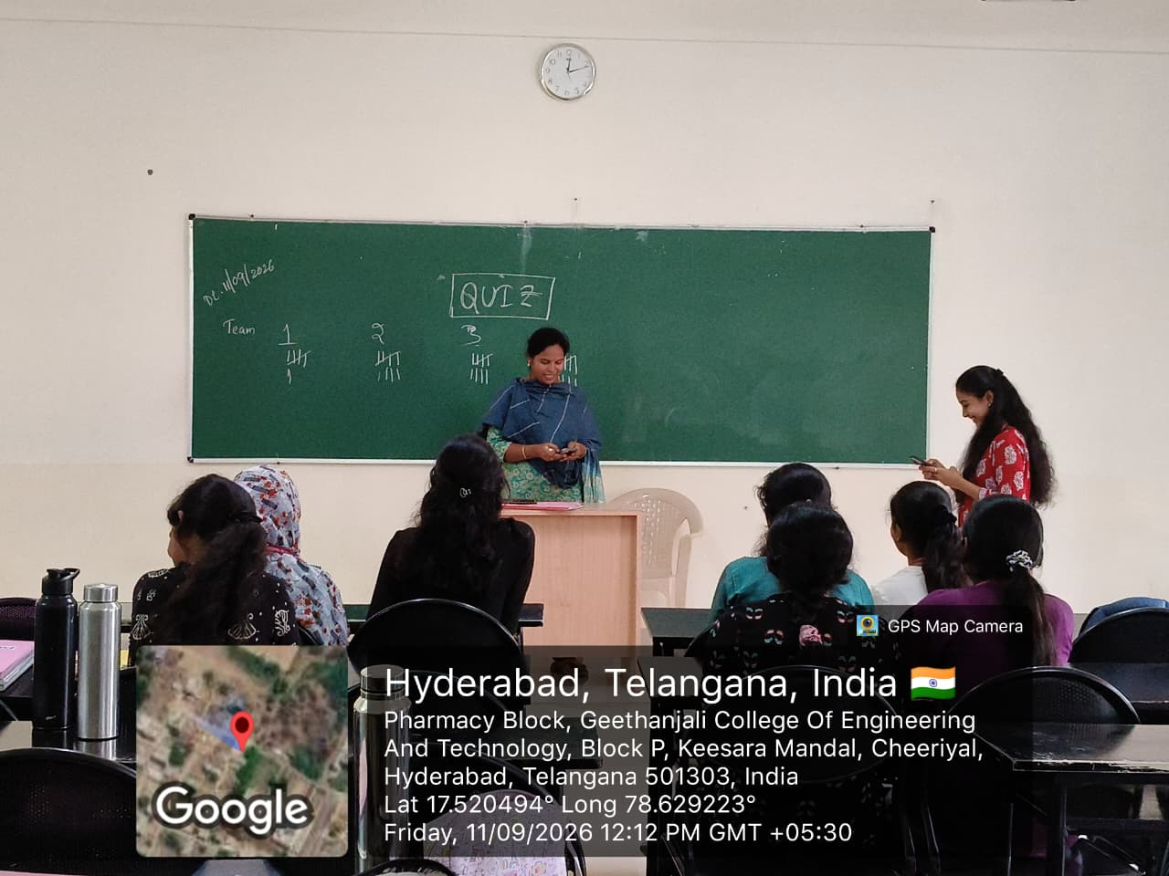

FACULTY HOD PRINCIPAL

Geethanjali College of Pharmacy

UGC AUTONOMOUS
Approved by PCI New Delhi, Affiliated to JNTUH, Accredited by NAAC with an A+ Grade,
Accredited by NBA (B. Pharmacy) Recognized by DSIR’s SIRO and ISO 9001:2015 Certified.
Cheeryal (V), Keesara (M), Medchal-Malkajgiri Dist.- Telangana State- 501303.
FLIPPED CLASSROOM
Date: 07.05.2026
Name of the Faculty: Dr. A. Madhavi Designation: Associate Professor
Department: Pharmaceutical Analysis
Subject: Pharmaceutical Biochemistry Class: B. Pharmacy I Year II Sem
Topic: Ketone bodies formation and utilization
Timings: 1:50 pm to 2:40 pm
Description: Students were provided with pre-class learning material on ketone body formation and utilization, including the pathways, key enzymes, and physiological significance. During the classroom session, students discussed the pathway, analyzed the conditions leading to ketogenesis, and answered application-based questions to reinforce their understanding.
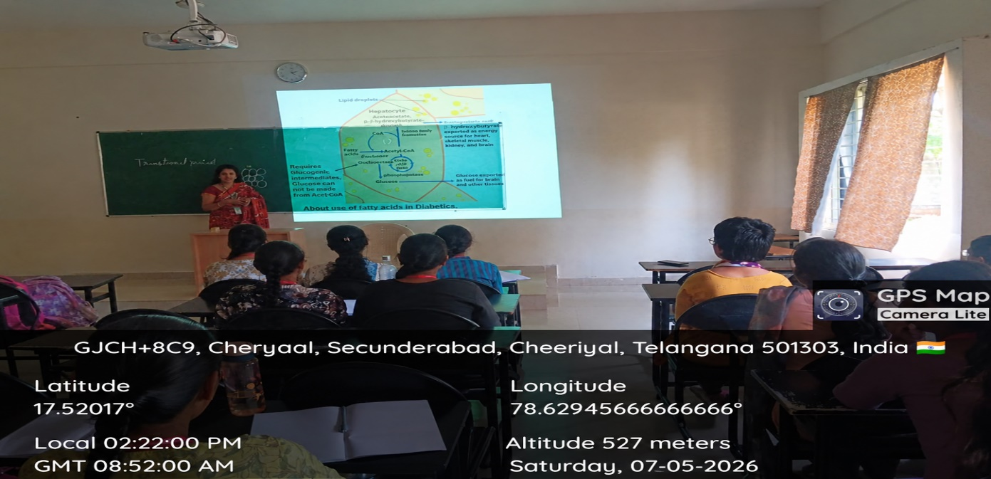

FACULTY HOD PRINCIPAL

